UNITED STATES

SECURITIES AND EXCHANGE COMMISSION
Washington, D.C. 20549

SCHEDULE 14A

Proxy Statement Pursuant to Section 14(a) of the
Securities Exchange Act of 1934

(Amendment No.)

Filed by the Registrant ☒

Filed by a Party other than the Registrant ☐

Check the appropriate box:

- Preliminary Proxy Statement

- Confidential, for Use of the Commission Only (as permitted by Rule 14a-6(e)(2))

- Definitive Proxy Statement

- Definitive Additional Materials

- Soliciting Material under §240.14a-12

NOV Inc.

(Name of Registrant as Specified In Its Charter)

(Name of Person(s) Filing Proxy Statement, if other than the Registrant)

Payment of Filing Fee (Check all boxes that apply):

- No fee required

- Fee paid previously with preliminary materials

- Fee computed on table in exhibit required by Item 25(b) per Exchange Act Rules 14a-6(i)(1) and 0-11



You invested in NOV INC. and it’s time to vote!

You have the right to vote on proposals being presented at the Annual Meeting. This is an important notice regarding the availability of proxy material for the stockholder meeting to be held on May 15, 2024.

Get informed before you vote

View the Notice & Proxy Statement, Form 10-K online OR you can receive a free paper or email copy of the material(s) by requesting prior to May 01, 2024. If you would like to request a copy of the material(s) for this and/or future stockholder meetings, you may (1) visit www.ProxyVote.com, (2) call 1-800-579-1639 or (3) send an email to sendmaterial@proxyvote.com. If sending an email, please include your control number (indicated below) in the subject line. Unless requested, you will not otherwise receive a paper or email copy.
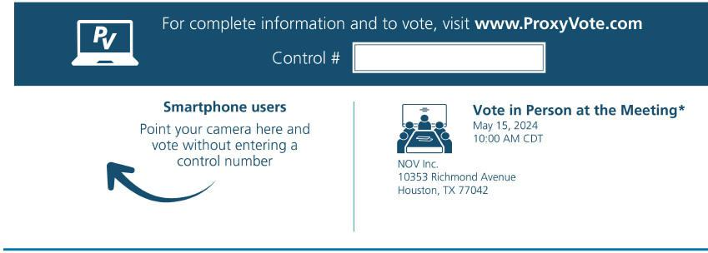

*Please check the meeting materials for any special requirements for meeting attendance. At the meeting, you will need to request a ballot to vote these shares.

- Vote at www.ProxyVote.com

- THIS IS NOT A VOTABLE BALLOT

This is an overview of the proposals being presented at the
upcoming stockholder meeting. Please follow the instructions
on the reverse side to vote these important matters.
 |  |  | Board
Voting Items |  |  | Recommends
1. | To elect ten nominees as directors of the Company for a term of one year.
 | Nominees:
1a. | Clay C. Williams |  | For
1b. | Greg L. Armstrong |  | For
1c. | Marcela E. Donadio |  | For
1d. | Ben A. Guill |  | For
1e. | David D. Harrison |  | For
1f. | Patricia Martinez |  | For
1g. | Eric L. Mattson |  | For
1h. | Patricia B. Melcher |  | For
1i. | William R. Thomas |  | For
1j. | Robert S. Welborn |  | For
2. | To ratify the appointment of Ernst & Young LLP as independent auditors of the Company for 2024. |  | For
3. | To approve, on an advisory basis, the compensation of our named executive officers. |  | For

NOTE: Such other business as may properly come before the meeting or any adjournment thereof.

Prefer to receive an email instead? While voting on www.ProxyVote.com, be sure to click “Sign up for E-delivery”.

