UNITED STATES
SECURITIES AND EXCHANGE COMMISSION
WASHINGTON, DC 20549

FORM 8-K

CURRENT REPORT
Pursuant to Section 13 or 15(d)
of the Securities Exchange Act of 1934
Date of report (Date of earliest event reported): July 28, 2026

NOV INC.
(Exact Name of Registrant as Specified in Charter)

Delaware |  | 1-12317 |  | 76-0475815
(State or Other Jurisdiction  of Incorporation) |  | (Commission  File Number) |  | (I.R.S. Employer  Identification No.)
10353 Richmond Ave.  Houston, Texas |  |  |  | 77042
(Address of Principal Executive Offices) |  |  |  | (Zip Code)
Registrant’s Telephone Number, Including Area Code 346-223-3000
(Former Name or Former Address, if Changed Since Last Report)

Check the appropriate box below if the Form 8-K filing is intended to simultaneously satisfy the filing obligation of the registrant under any of the following provisions (see General Instruction A.2. below):
 | ☐ | Written communication pursuant to Rule 425 under the Securities Act (17 CFR 230.425)
 | ☐ | Soliciting material pursuant to Rule 14a-12 under the Exchange Act (17 CFR 240.14a-12)
 | ☐ | Pre-commencement communication pursuant to Rule 14d-2(b) under the Exchange Act (17 CFR 240.14d-2(b))
 | ☐ | Pre-commencement communication pursuant to Rule 13e-4(c) under the Exchange Act (17 CFR 240.13e-4(c))
Securities registered pursuant to Section 12(b) of the Act:
Title of each class |  | Trading Symbol(s) |  | Name of each exchange on which registered
Common Stock, par value $0.01 per share |  | NOV |  | New York Stock Exchange
Indicate by check mark whether the registrant is an emerging growth company as defined in Rule 405 of the Securities Act of 1933 (§230.405 of this chapter) or Rule 12b-2 of the Securities Exchange Act of 1934 (§240.12b-2 of this chapter).
Emerging growth company ☐
If an emerging growth company, indicate by check mark if the registrant has elected not to use the extended transition period for complying with any new or revised financial accounting standards provided pursuant to Section 13(a) of the Exchange Act. ☐

Item 2.02 Results of Operations and Financial Condition
On July 28, 2026, NOV Inc. (the “Company”) issued a press release announcing earnings for the quarter ended June 30, 2026 and conference call in connection therewith. A copy of the release is furnished herewith as Exhibit 99.1 and incorporated herein by reference. A presentation to accompany the conference call, which contains certain historical and forward-looking information relating to the Company (the “Presentation Materials”), has been made available on its website at www.nov.com. A copy of the Presentation Materials is attached hereto as Exhibit 99.2 and incorporated herein by reference.

Forward-Looking Statements
This report on Form 8-K contains forward-looking statements within the meaning of the Private Securities Litigation Reform Act of 1995. Such statements are subject to a number of risks, uncertainties and assumptions, including the factors described in the Company’s most recent periodic reports and other documents filed with the Securities and Exchange Commission (the “SEC”), which are available free of charge at the SEC’s website at www.sec.gov or the Company’s website at www.nov.com. The Company cautions you that forward-looking statements are not guarantees of future performance and that actual results or developments may differ materially from those projected or implied in these statements.

Item 9.01 Financial Statements and Exhibits
(d) Exhibits
The following exhibits are provided as part of the information furnished under Item 2.02 of this Current Report on Form 8-K:
99.1 |  | NOV Inc. press release dated July 28, 2026 announcing the earnings results for the quarter ended June 30, 2026.
99.2 |  | Presentation Materials dated July 29, 2026.
104 |  | Cover Page Interactive Data File (embedded within the Inline XBRL document).

SIGNATURES
Pursuant to the requirements of the Securities Exchange Act of 1934, the registrant has duly caused this report to be signed on its behalf by the undersigned hereunto duly authorized.

Date: July 29, 2026 |  |  |  | NOV INC.
 |  |  |  | /s/ Peter F. Vranderic
 |  |  |  | Peter F. Vranderic
 |  |  |  | Vice President

Exhibit 99.1


NEWS | Contact: Amie D'Ambrosio (713) 375-3826

FOR IMMEDIATE RELEASE

NOV Reports Second quarter 2026 EARNINGS

•
Revenues of $2.13 billion, up 4% sequentially and down 2% year-over-year
•
Net income of $112 million, or $0.31 per share, an increase of $93 million sequentially and $4 million year-over-year
•
Adjusted EBITDA1,2 of $283 million, an increase of $106 million sequentially and $31 million year-over-year
•
Returned $127 million of capital to shareholders through share repurchases and dividends
•
Bookings of $474 million, representing a book-to-bill of 74%

1 Free Cash Flow, Excess Free Cash Flow, Adjusted operating profit, and Adjusted EBITDA are non-GAAP measures, see “Non-GAAP Financial Measures,” and “Reconciliation of GAAP to non-GAAP measures” below.
2 Second quarter 2026 Adjusted EBITDA includes a benefit of approximately $40 million related to tariff refunds

HOUSTON, TX, July 28, 2026  NOV Inc. (NYSE: NOV) today reported second quarter 2026 revenues of $2.13 billion, an increase of four percent sequentially and a decrease of two percent compared to the second quarter of 2025. Net income increased $4 million, or $0.02 per diluted share, year-over-year to $112 million. Operating profit was $193 million, or 9.0 percent of sales, an increase of 35 percent versus the second quarter of 2025. Adjusted operating profit was $190 million, an increase of 15 percent versus the second quarter of 2025. Adjusted EBITDA increased $31 million year-over-year to $283 million, or 13.3 percent of sales. Second quarter 2026 Adjusted operating profit and Adjusted EBITDA include a benefit of approximately $40 million related to tariff refunds.

“NOV’s second quarter results reflect outstanding execution by our team in a market that is demonstrating significantly improved underlying industry fundamentals,” said Jose Bayardo, Chairman, President, and CEO. “During the second quarter, we were better able to navigate the continued logistical challenges in the Middle East, while our businesses benefited from improving demand in most major regions.

“While recent price volatility and geopolitical uncertainty continue to cause temporary disruptions and project deferrals, we are encouraged by a growing pipeline of capital equipment opportunities and improving short cycle activity across most markets. Additionally, it is becoming increasingly apparent that depleting inventories and significantly heightened focus on energy security, combined with a decade of constrained investments in the industry’s asset base, is starting a synchronized global recovery that should drive meaningful demand for NOV’s technology and equipment over the next several years.

“We believe the actions our organization is taking, including continued investment in the development of superior solutions for our customers and initiatives to drive efficiencies across our operations, position NOV to demonstrate meaningfully higher earnings over the coming years.”
- 1 -

Energy Equipment
Energy Equipment generated revenues of $1.22 billion in the second quarter of 2026, an increase of one percent from the second quarter of 2025. Operating profit increased $55 million from the prior year to $177 million, or 14.5 percent of sales, and included $2 million in pre-tax Other Items and a $7 million gain on sales of fixed assets. Adjusted EBITDA increased $42 million from the prior year to $200 million, or 16.4 percent of sales, and includes a benefit of approximately $14 million related to tariff refunds. Strong execution on offshore production projects nearing completion and a more favorable sales mix drove the improvement in revenue and profitability.

New orders booked during the quarter totaled $474 million, an increase of $54 million when compared to the $420 million of new orders booked during the second quarter of 2025. Orders shipped from backlog were $638 million, representing a book-to-bill of 74 percent and an increase of $6 million when compared to the $632 million orders shipped and a 66 percent book-to-bill during the second quarter of 2025. As of June 30, 2026, backlog for capital equipment orders for Energy Equipment totaled $4.08 billion, a decrease of $220 million from June 30, 2025.

Energy Products and Services
Energy Products and Services generated revenues of $974 million in the second quarter of 2026, a decrease of five percent from the second quarter of 2025. Operating profit increased $2 million from the prior year to $85 million, or 8.7 percent of sales, and included $9 million in pre-tax Other Items and a $13 million gain on sales of fixed assets. Adjusted EBITDA decreased $2 million from the prior year to $144 million, or 14.8 percent of sales, and includes a benefit of approximately $26 million related to tariff refunds. Market share gains by the segment’s drill bit and artificial lift operations and continued growth in digital services were more than offset by lower capital equipment sales, despite orders booked in the first half of 2026 that are expected to support higher shipments in the second half of the year.

Third Quarter 2026 Outlook
The Company is providing financial guidance for the third quarter of 2026, which constitutes “forward-looking statements” as described further below under “Cautionary Note Regarding Forward-Looking Statements.” This guidance is subject to, and may be affected by, the current uncertainty and conflict in the Middle East, and assumes that the operating environment in the region remains consistent with the conditions experienced during the second quarter. A worsening of such conditions may cause actual results to differ materially from this guidance.

For the third quarter of 2026, management expects year-over-year consolidated revenues to be flat to up 2 percent, with Adjusted EBITDA expected to be between $240 million and $270 million.

Corporate Information
NOV repurchased approximately 3.2 million shares of common stock for $63 million and paid $64 million in dividends during the second quarter, resulting in a total of $127 million in capital returned to shareholders.

During the second quarter of 2026, NOV recorded $17 million in pre-tax Other Items, primarily related to severance and facility closures, and costs associated with streamlining our business operations (see Reconciliation of GAAP to non-GAAP measures).

As of June 30, 2026, the Company had total debt of $1,706 million, with $1.50 billion available on its revolving credit facility, and $1,164 million in cash and cash equivalents.
- 2 -

Significant Achievements
NOV won orders for production processing equipment and seawater treatment systems for offshore developments across multiple regions. NOV will provide gas dehydration and seawater treatment systems for a newbuild FPSO that will be used in West Africa. Additionally, NOV won orders for multiple FPSO topside modules and subsea structures for an offshore gas field development in Indonesia. As offshore investment increases, customers continue to rely on NOV’s leading production processing technologies for complex offshore developments.

NOV developed and implemented an AI-enabled solution that integrates real-time equipment diagnostics into the operation of a Norwegian operator’s sulphate removal unit to help optimize performance. Supplementing NOV’s operational support services, the solution allows NOV’s AI-agent to interface directly with the operator’s AI-agent to recommend maintenance actions using the Max Platform. The solution demonstrates NOV’s ability to collaborate closely with leading operators and leverage its engineering and equipment expertise to create differentiated digital solutions that reduce operating costs and maximize productivity.

NOV was selected to supply its Bondstrand fiberglass piping systems for an FPSO destined for a deepwater development in Suriname. The scope includes over 3,000 meters of pipe, with diameters ranging from 2 in. to 40 in., for handling critical water services across the vessel. The project further strengthens NOV’s leadership in offshore production infrastructure and demonstrates sustained demand for fiberglass piping systems in corrosive, weight-sensitive offshore applications.

NOV secured drill pipe awards for offshore drilling projects in Brazil and Suriname. The awards include new drill pipe string configurations with NOV’s proprietary Delta connection technology. Reflecting increased offshore demand, these orders contributed to strong drill pipe order intake during the first half of the year.

NOV was awarded orders to supply Tuboscope Zap-Lok mechanical interference connection technology for subsea gas pipeline projects in West Africa and Southeast Asia. The projects include the first deployment of Zap-Lok technology in Nigeria and a repeat award in Malaysia, demonstrating customer confidence in the technology. Zap-Lok provides a safer, faster, and more cost-effective alternative to conventional welded pipeline installation, helping operators accelerate pipeline construction while reducing installation risk.

NOV’s robotics and automation technologies continued to gain traction with new orders for ATOM RTX robotics packages and NOVOS automation systems across offshore and land drilling operations. Following successful deployment in the Permian Basin, NOV received additional orders for its ATOM RTX robotics packages to expand hands-free pipe handling and rig floor automation on onshore rigs. NOV also secured NOVOS automation orders for several offshore and land rigs. Adoption of NOV’s robotics and automation technologies continues to increase as customers realize the benefits of improved safety, efficiency, and drilling performance.

NOV signed an agreement with a major oil and gas operator to deploy its Downhole Broadband Solutions for an upcoming North Sea drilling campaign, with operations expected to begin in 2027. Enabled by NOV’s proprietary wired drill pipe, the solution will provide real-time, high-density downhole data from the bottomhole assembly and along the drill string. This enhanced visibility is designed to improve drilling performance and optimize well placement to maximize well productivity.
- 3 -

NOV deployed a remote service rig monitoring solution through its Max Completions offering for a supermajor, enabling centralized oversight of its workover operations through real-time operational visibility and improved reporting accuracy. Additionally, NOV expanded its digital portfolio through the acquisition of Rigsmart and Cranesmart, further complementing NOV’s existing wireless monitoring, safety, and data acquisition technologies. Together, these developments strengthen NOV’s ability to provide digital technologies across a broad range of end-markets.

NOV secured a new contract for its XLC-S connector with a regional operator in Egypt. The XLC-S offshore conductor casing connector wedge thread design provides enhanced strength and high torque resistance, enabling reliable field performance. The award expands adoption of XLC-S connector technology in a strategic offshore market and illustrates customer demand for reliable, high-performance connector solutions.

NOV secured a large order to supply underground composite fuel storage tanks to support a customer’s retail fueling expansion across the Upper Midwest and Northeast U.S. This award builds on the strong momentum in fuel storage tank demand, with bookings nearly doubling over the prior 18-month period. As investment in retail fueling infrastructure expands, NOV is well positioned to support customers with advanced fiberglass storage solutions.

NOV secured a multiyear contract to provide real-time data acquisition, delivery, and visualization services for a leading Latin American operator’s drilling and completion operations. NOV’s Max Platform will provide improved operational visibility across the customer’s operations, improving workflows and supporting better and faster data-driven decision making.

NOV’s PosiTrack torsional vibration mitigation technology gained traction in offshore markets with successful deployments in Norway, Brazil and West Africa during the quarter. In offshore West Africa, the tool was deployed in an 8½-in. production section as part of a rotary steerable system and logging-while-drilling bottomhole assembly to mitigate vibration risks while drilling through hard stringers. PosiTrack helped the operator drill the section more than 2.5 days ahead of plan, improving drilling performance and reducing schedule risk in a challenging offshore application.

- 4 -

Second Quarter Earnings Conference Call
NOV will hold a conference call to discuss its second quarter 2026 results on July 29, 2026 at 10:00 AM Central Time (11:00 AM Eastern Time). The call will be broadcast simultaneously at www.nov.com/investors. A replay will be available on the website for 30 days.

About NOV
NOV (NYSE: NOV) delivers technology-driven solutions to empower the global energy industry. For more than 160 years, NOV has pioneered innovations that enable its customers to safely and efficiently produce abundant energy while minimizing environmental impact. NOV powers the industry that powers the world.
Visit www.nov.com for more information.

Non-GAAP Financial Measures
This press release contains certain non-GAAP financial measures that management believes are useful tools for internal use and the investment community in evaluating NOV’s overall financial performance. These non-GAAP financial measures are broadly used to value and compare companies in the oilfield services and equipment industry. Not all companies define these measures in the same way. In addition, these non-GAAP financial measures are not a substitute for financial measures prepared in accordance with GAAP and should therefore be considered only as supplemental to such GAAP financial measures. Additionally, Free Cash Flow and Excess Free Cash Flow do not represent the Company’s residual cash flow available for discretionary expenditures, as the calculation of these measures does not account for certain debt service requirements or other non-discretionary expenditures. Please see the attached schedules for reconciliations of the differences between the non-GAAP financial measures used in this press release and the most directly comparable GAAP financial measures.

This press release contains certain forward-looking non-GAAP financial measures, including Adjusted EBITDA. The Company has not provided a reconciliation of projected net income to projected Adjusted EBITDA because management cannot predict with a reasonable degree of accuracy certain of the necessary components of net income, such as other income (expense), which includes fluctuations in foreign currencies. As such, a reconciliation of projected net income to projected Adjusted EBITDA is not available without unreasonable effort. The actual amount of other income (expense), provision (benefit) for income taxes, equity income (loss) in unconsolidated affiliates, depreciation and amortization, and other amounts excluded from Adjusted EBITDA could have a significant impact on net income.

- 5 -

Cautionary Note Regarding Forward-Looking Statements
This document contains, or has incorporated by reference, statements that are not historical facts, including estimates, projections, and statements relating to our business plans, objectives, and expected operating results that are “forward-looking statements” within the meaning of the Private Securities Litigation Reform Act of 1995. Such statements often contain words such as “may,” “can,” “likely,” “believe,” “plan,” “predict,” “potential,” “will,” “intend,” “think,” “should,” “expect,” “anticipate,” “estimate,” “forecast,” “expectation,” “goal,” “outlook,” “projected,” “projections,” “target,” and other similar words, although some such statements are expressed differently. Other oral or written statements we release to the public may also contain forward-looking statements. Forward-looking statements involve risk and uncertainties and reflect our best judgment based on current information. You should be aware that our actual results could differ materially from results anticipated in such forward-looking statements due to a number of factors, including but not limited to changes in oil and gas prices, customer demand for our products, challenges related to NOV’s operations in the Middle East, potential catastrophic events related to our operations, protection of intellectual property rights, compliance with laws, and worldwide economic activity, including matters related to recent Russian sanctions and changes in U.S. trade policies, including the imposition of tariffs and retaliatory tariffs and their related impacts on the economy. Given these uncertainties, current or prospective investors are cautioned not to place undue reliance on any such forward-looking statements. We undertake no obligation to update any such factors or forward-looking statements to reflect future events or developments. You should also consider carefully the statements under “Risk Factors,” as disclosed in our most recent Annual Report on Form 10-K, as updated in Part II, Item 1A of our most recent Quarterly Report on Form 10-Q, and “Management’s Discussion and Analysis of Financial Condition and Results of Operations” of our most recent Annual Report on Form 10-K, which address additional factors that could cause our actual results to differ from those set forth in such forward-looking statements, as well as additional disclosures we make in our press releases and other securities filings. We also suggest that you listen to our quarterly earnings release conference calls with financial analysts.

Certain prior period amounts have been reclassified in this press release to be consistent with current period presentation.

CONTACT:
Amie D'Ambrosio
Director, Investor Relations
(713) 375-3826
Amie.DAmbrosio@nov.com
- 6 -

NOV INC.
CONSOLIDATED STATEMENTS OF INCOME (Unaudited)
(In millions, except per share data)

 |  | Three Months Ended |  |  |  |  |  |  |  |  |  |  |  | Six Months Ended
 |  | June 30, |  |  |  |  |  |  |  | March 31, |  |  |  | June 30,
 |  | 2026 |  |  |  | 2025 |  |  |  | 2026 |  |  |  | 2026 |  |  |  | 2025
Revenue:
Energy Equipment |  | $ | 1,218 |  |  | $ | 1,207 |  |  | $ | 1,190 |  |  | $ | 2,408 |  |  | $ | 2,353
Energy Products and Services |  |  | 974 |  |  |  | 1,025 |  |  |  | 897 |  |  |  | 1,871 |  |  |  | 2,017
Eliminations |  |  | (58 | ) |  |  | (44 | ) |  |  | (35 | ) |  |  | (93 | ) |  |  | (79 | )
Total revenue |  |  | 2,134 |  |  |  | 2,188 |  |  |  | 2,052 |  |  |  | 4,186 |  |  |  | 4,291
Gross profit |  |  | 521 |  |  |  | 446 |  |  |  | 379 |  |  |  | 900 |  |  |  | 893
Gross profit % |  |  | 24.4 | % |  |  | 20.4 | % |  |  | 18.5 | % |  |  | 21.5 | % |  |  | 20.8 | %
Selling, general, and administrative |  |  | 328 |  |  |  | 303 |  |  |  | 332 |  |  |  | 660 |  |  |  | 598
Operating profit |  |  | 193 |  |  |  | 143 |  |  |  | 47 |  |  |  | 240 |  |  |  | 295
Interest expense, net |  |  | (13 | ) |  |  | (12 | ) |  |  | (11 | ) |  |  | (24 | ) |  |  | (23 | )
Equity income (loss) in unconsolidated affiliates |  |  | (5 | ) |  |  | 1 |  |  |  | (3 | ) |  |  | (8 | ) |  |  | 1
Other income (expense), net |  |  | (18 | ) |  |  | (17 | ) |  |  | 2 |  |  |  | (16 | ) |  |  | (37 | )
Income before income taxes |  |  | 157 |  |  |  | 115 |  |  |  | 35 |  |  |  | 192 |  |  |  | 236
Provision for income taxes |  |  | 41 |  |  |  | 1 |  |  |  | 15 |  |  |  | 56 |  |  |  | 48
Net income |  |  | 116 |  |  |  | 114 |  |  |  | 20 |  |  |  | 136 |  |  |  | 188
Net income attributable to noncontrolling interests |  |  | 4 |  |  |  | 6 |  |  |  | 1 |  |  |  | 5 |  |  |  | 7
Net income attributable to Company |  | $ | 112 |  |  | $ | 108 |  |  | $ | 19 |  |  | $ | 131 |  |  | $ | 181
Per share data:
Basic |  | $ | 0.31 |  |  | $ | 0.29 |  |  | $ | 0.05 |  |  | $ | 0.36 |  |  | $ | 0.48
Diluted |  | $ | 0.31 |  |  | $ | 0.29 |  |  | $ | 0.05 |  |  | $ | 0.36 |  |  | $ | 0.48
Weighted average shares outstanding:
Basic |  |  | 359 |  |  |  | 375 |  |  |  | 361 |  |  |  | 360 |  |  |  | 378
Diluted |  |  | 362 |  |  |  | 376 |  |  |  | 364 |  |  |  | 364 |  |  |  | 380

- 7 -

NOV INC.
CONSOLIDATED BALANCE SHEETS (Unaudited)
(In millions)

 |  | June 30, |  |  |  | December 31,
 |  | 2026 |  |  |  | 2025
ASSETS |  | (Unaudited)
Current assets:
Cash and cash equivalents |  | $ | 1,164 |  |  | $ | 1,552
Receivables, net |  |  | 1,813 |  |  |  | 1,701
Inventories, net |  |  | 1,947 |  |  |  | 1,799
Contract assets |  |  | 666 |  |  |  | 596
Prepaid and other current assets |  |  | 199 |  |  |  | 172
Total current assets |  |  | 5,789 |  |  |  | 5,820
Property, plant and equipment, net |  |  | 2,016 |  |  |  | 2,050
Lease right-of-use assets |  |  | 500 |  |  |  | 502
Goodwill and intangibles, net |  |  | 2,022 |  |  |  | 2,037
Other assets |  |  | 872 |  |  |  | 882
Total assets |  | $ | 11,199 |  |  | $ | 11,291
LIABILITIES AND STOCKHOLDERS’ EQUITY
Current liabilities:
Accounts payable |  | $ | 858 |  |  | $ | 831
Accrued liabilities |  |  | 781 |  |  |  | 822
Contract liabilities |  |  | 596 |  |  |  | 565
Current portion of lease liabilities |  |  | 100 |  |  |  | 101
Current portion of long-term debt |  |  | 14 |  |  |  | 30
Accrued income taxes |  |  | 41 |  |  |  | 57
Total current liabilities |  |  | 2,390 |  |  |  | 2,406
Long-term debt |  |  | 1,692 |  |  |  | 1,688
Lease liabilities |  |  | 520 |  |  |  | 521
Other liabilities |  |  | 336 |  |  |  | 354
Total liabilities |  |  | 4,938 |  |  |  | 4,969
Total stockholders’ equity |  |  | 6,261 |  |  |  | 6,322
Total liabilities and stockholders’ equity |  | $ | 11,199 |  |  | $ | 11,291

- 8 -

NOV INC.
CONSOLIDATED STATEMENTS OF CASH FLOWS (Unaudited)
(In millions)

 |  | Three Months Ended |  |  |  | Six Months Ended
 |  | June 30, |  |  |  | June 30,
 |  | 2026 |  |  |  | 2026 |  |  |  | 2025
Cash flows from operating activities:
Net income |  | $ | 116 |  |  | $ | 136 |  |  | $ | 188
Adjustments to reconcile net income to net cash provided by (used in) operating activities:
Depreciation and amortization |  |  | 93 |  |  |  | 185 |  |  |  | 176
Working capital, net |  |  | (174 | ) |  |  | (395 | ) |  |  | (135 | )
Other operating items, net |  |  | (18 | ) |  |  | 65 |  |  |  | 97
Net cash provided by (used in) operating activities |  |  | 17 |  |  |  | (9 | ) |  |  | 326
Cash flows from investing activities:
Purchases of property, plant and equipment |  |  | (81 | ) |  |  | (146 | ) |  |  | (167 | )
Business acquisitions, net of cash acquired |  |  | (13 | ) |  |  | (13 | ) |  |  | —
Proceeds from sales of fixed assets |  |  | 44 |  |  |  | 45 |  |  |  | 5
Net cash used in investing activities |  |  | (50 | ) |  |  | (114 | ) |  |  | (162 | )
Cash flows from financing activities:
Payments against lines of credit and other debt |  |  | (9 | ) |  |  | (13 | ) |  |  | (13 | )
Cash dividends paid |  |  | (64 | ) |  |  | (97 | ) |  |  | (135 | )
Share repurchases |  |  | (63 | ) |  |  | (130 | ) |  |  | (150 | )
Other |  |  | (12 | ) |  |  | (23 | ) |  |  | (35 | )
Net cash used in financing activities |  |  | (148 | ) |  |  | (263 | ) |  |  | (333 | )
Effect of exchange rates on cash |  |  | 3 |  |  |  | (2 | ) |  |  | 19
Decrease in cash and cash equivalents |  |  | (178 | ) |  |  | (388 | ) |  |  | (150 | )
Cash and cash equivalents, beginning of period |  |  | 1,342 |  |  |  | 1,552 |  |  |  | 1,230
Cash and cash equivalents, end of period |  | $ | 1,164 |  |  | $ | 1,164 |  |  | $ | 1,080

- 9 -

NOV INC.
RECONCILIATION OF GAAP TO NON-GAAP MEASURES (Unaudited)
(In millions)
Presented below is a reconciliation of cash flow from operating activities to “Free Cash Flow”. The Company defines Free Cash Flow as cash flow from operating activities less purchases of property, plant and equipment, or “capital expenditures” and Excess Free Cash Flow as cash flows from operations less capital expenditures and other investments, including acquisitions and divestitures. Management believes this is important information to provide because it is used by management to evaluate the Company’s operational performance and trends between periods and manage the business. Management also believes this information may be useful to investors and analysts to gain a better understanding of the Company’s results of ongoing operations. Free Cash Flow and Excess Free Cash Flow are not intended to replace GAAP financial measures.
 |  | Three Months Ended |  |  |  | Six Months Ended
 |  | June 30, |  |  |  | June 30,
 |  | 2026 |  |  |  | 2026 |  |  |  | 2025
Total cash flows provided by (used in) operating activities |  | $ | 17 |  |  | $ | (9 | ) |  | $ | 326
Capital expenditures |  |  | (81 | ) |  |  | (146 | ) |  |  | (167 | )
Free Cash Flow |  | $ | (64 | ) |  | $ | (155 | ) |  | $ | 159
Business acquisitions, net of cash acquired |  |  | (13 | ) |  |  | (13 | ) |  |  | —
Business divestitures, net of cash disposed |  |  | — |  |  |  | — |  |  |  | —
Excess Free Cash Flow |  | $ | (77 | ) |  | $ | (168 | ) |  | $ | 159

- 10 -

NOV INC.
RECONCILIATION OF GAAP TO NON-GAAP MEASURES, CONT. (Unaudited)
(In millions)
Presented below is a reconciliation of operating profit to Adjusted operating profit and Net Income to Adjusted EBITDA. The Company defines Adjusted operating profit as operating profit excluding gains and losses on sales of fixed assets, and, when applicable, pre-tax Other Items. The Company defines Adjusted EBITDA as operating profit excluding depreciation, amortization, gains and losses on sales of fixed assets, and, when applicable, pre-tax Other Items. Adjusted EBITDA % is a ratio showing Adjusted EBITDA as a percentage of sales. Management believes this is important information to provide because it is used by management to evaluate the Company’s operational performance and trends between periods and manage the business. Management also believes this information may be useful to investors and analysts to gain a better understanding of the Company’s results of ongoing operations. Adjusted operating profit, Adjusted EBITDA and Adjusted EBITDA % are not intended to replace GAAP financial measures, such as Net Income and operating profit %. Pre-tax Other Items include gain on business divestiture, impairment, restructure, severance, facility closure costs and inventory charges and credits.
 |  | Three Months Ended |  |  |  |  |  |  |  |  |  |  |  | Six Months Ended
 |  | June 30, |  |  |  |  |  |  |  | March 31, |  |  |  | June 30,
 |  | 2026 |  |  |  | 2025 |  |  |  | 2026 |  |  |  | 2026 |  |  |  | 2025
Operating profit:
Energy Equipment |  | $ | 177 |  |  | $ | 122 |  |  | $ | 93 |  |  | $ | 270 |  |  | $ | 256
Energy Products and Services |  |  | 85 |  |  |  | 83 |  |  |  | 26 |  |  |  | 111 |  |  |  | 166
Eliminations and corporate costs |  |  | (69 | ) |  |  | (62 | ) |  |  | (72 | ) |  |  | (141 | ) |  |  | (127 | )
Total operating profit |  | $ | 193 |  |  | $ | 143 |  |  | $ | 47 |  |  | $ | 240 |  |  | $ | 295
Operating profit %:
Energy Equipment |  |  | 14.5 | % |  |  | 10.1 | % |  |  | 7.8 | % |  |  | 11.2 | % |  |  | 10.9 | %
Energy Products and Services |  |  | 8.7 | % |  |  | 8.1 | % |  |  | 2.9 | % |  |  | 5.9 | % |  |  | 8.2 | %
Eliminations and corporate costs |  |  | — |  |  |  | — |  |  |  | — |  |  |  | — |  |  |  | —
Total operating profit % |  |  | 9.0 | % |  |  | 6.5 | % |  |  | 2.3 | % |  |  | 5.7 | % |  |  | 6.9 | %
Pre-tax Other Items, net:
Energy Equipment |  | $ | 2 |  |  | $ | 9 |  |  | $ | 9 |  |  | $ | 11 |  |  | $ | 12
Energy Products and Services |  |  | 9 |  |  |  | 6 |  |  |  | 8 |  |  |  | 17 |  |  |  | 11
Corporate |  |  | 6 |  |  |  | 4 |  |  |  | 20 |  |  |  | 26 |  |  |  | 9
Total pre-tax Other Items |  | $ | 17 |  |  | $ | 19 |  |  | $ | 37 |  |  | $ | 54 |  |  | $ | 32
(Gain) loss on sales of fixed assets:
Energy Equipment |  | $ | (7 | ) |  | $ | (1 | ) |  | $ | — |  |  | $ | (7 | ) |  | $ | (1 | )
Energy Products and Services |  |  | (13 | ) |  |  | — |  |  |  | 1 |  |  |  | (12 | ) |  |  | (2 | )
Corporate |  |  | — |  |  |  | 4 |  |  |  | — |  |  |  | — |  |  |  | 4
Total (gain) loss on sales of fixed assets |  | $ | (20 | ) |  | $ | 3 |  |  | $ | 1 |  |  | $ | (19 | ) |  | $ | 1
Adjusted operating profit:
Energy Equipment |  | $ | 172 |  |  | $ | 130 |  |  | $ | 102 |  |  | $ | 274 |  |  | $ | 267
Energy Products and Services |  |  | 81 |  |  |  | 89 |  |  |  | 35 |  |  |  | 116 |  |  |  | 175
Eliminations and corporate costs |  |  | (63 | ) |  |  | (54 | ) |  |  | (52 | ) |  |  | (115 | ) |  |  | (114 | )
Adjusted operating profit |  | $ | 190 |  |  | $ | 165 |  |  | $ | 85 |  |  | $ | 275 |  |  | $ | 328
Depreciation & amortization:
Energy Equipment |  | $ | 28 |  |  | $ | 28 |  |  | $ | 29 |  |  | $ | 57 |  |  | $ | 56
Energy Products and Services |  |  | 63 |  |  |  | 57 |  |  |  | 61 |  |  |  | 124 |  |  |  | 116
Corporate |  |  | 2 |  |  |  | 2 |  |  |  | 2 |  |  |  | 4 |  |  |  | 4
Total depreciation & amortization |  | $ | 93 |  |  | $ | 87 |  |  | $ | 92 |  |  | $ | 185 |  |  | $ | 176
Adjusted EBITDA:
Energy Equipment |  | $ | 200 |  |  | $ | 158 |  |  | $ | 131 |  |  | $ | 331 |  |  | $ | 323
Energy Products and Services |  |  | 144 |  |  |  | 146 |  |  |  | 96 |  |  |  | 240 |  |  |  | 291
Eliminations and corporate costs |  |  | (61 | ) |  |  | (52 | ) |  |  | (50 | ) |  |  | (111 | ) |  |  | (110 | )
Total Adjusted EBITDA |  | $ | 283 |  |  | $ | 252 |  |  | $ | 177 |  |  | $ | 460 |  |  | $ | 504
Adjusted EBITDA %:
Energy Equipment |  |  | 16.4 | % |  |  | 13.1 | % |  |  | 11.0 | % |  |  | 13.7 | % |  |  | 13.7 | %
Energy Products and Services |  |  | 14.8 | % |  |  | 14.2 | % |  |  | 10.7 | % |  |  | 12.8 | % |  |  | 14.4 | %
Eliminations and corporate costs |  |  | — |  |  |  | — |  |  |  | — |  |  |  | — |  |  |  | —
Total Adjusted EBITDA % |  |  | 13.3 | % |  |  | 11.5 | % |  |  | 8.6 | % |  |  | 11.0 | % |  |  | 11.7 | %

- 11 -

NOV INC.
RECONCILIATION OF GAAP TO NON-GAAP MEASURES, CONT. (Unaudited)
(In millions)
 |  | Three Months Ended |  |  |  |  |  |  |  |  |  |  |  | Six Months Ended
 |  | June 30, |  |  |  |  |  |  |  | March 31, |  |  |  | June 30,
 |  | 2026 |  |  |  | 2025 |  |  |  | 2026 |  |  |  | 2026 |  |  |  | 2025
Reconciliation of Adjusted operating profit and Adjusted EBITDA:
GAAP net income attributable to Company |  | $ | 112 |  |  | $ | 108 |  |  | $ | 19 |  |  | $ | 131 |  |  | $ | 181
Noncontrolling interests |  |  | 4 |  |  |  | 6 |  |  |  | 1 |  |  |  | 5 |  |  |  | 7
Provision for income taxes |  |  | 41 |  |  |  | 1 |  |  |  | 15 |  |  |  | 56 |  |  |  | 48
Interest and financial costs |  |  | 21 |  |  |  | 22 |  |  |  | 22 |  |  |  | 43 |  |  |  | 44
Interest income |  |  | (8 | ) |  |  | (10 | ) |  |  | (11 | ) |  |  | (19 | ) |  |  | (21 | )
Equity (income) loss in unconsolidated affiliates |  |  | 5 |  |  |  | (1 | ) |  |  | 3 |  |  |  | 8 |  |  |  | (1 | )
Other (income) expense, net |  |  | 18 |  |  |  | 17 |  |  |  | (2 | ) |  |  | 16 |  |  |  | 37
(Gain) loss on sales of fixed assets |  |  | (20 | ) |  |  | 3 |  |  |  | 1 |  |  |  | (19 | ) |  |  | 1
Pre-tax Other Items, net |  |  | 17 |  |  |  | 19 |  |  |  | 37 |  |  |  | 54 |  |  |  | 32
Adjusted operating profit |  |  | 190 |  |  |  | 165 |  |  |  | 85 |  |  |  | 275 |  |  |  | 328
Depreciation and amortization |  |  | 93 |  |  |  | 87 |  |  |  | 92 |  |  |  | 185 |  |  |  | 176
Total Adjusted EBITDA |  | $ | 283 |  |  | $ | 252 |  |  | $ | 177 |  |  | $ | 460 |  |  | $ | 504

- 12 -

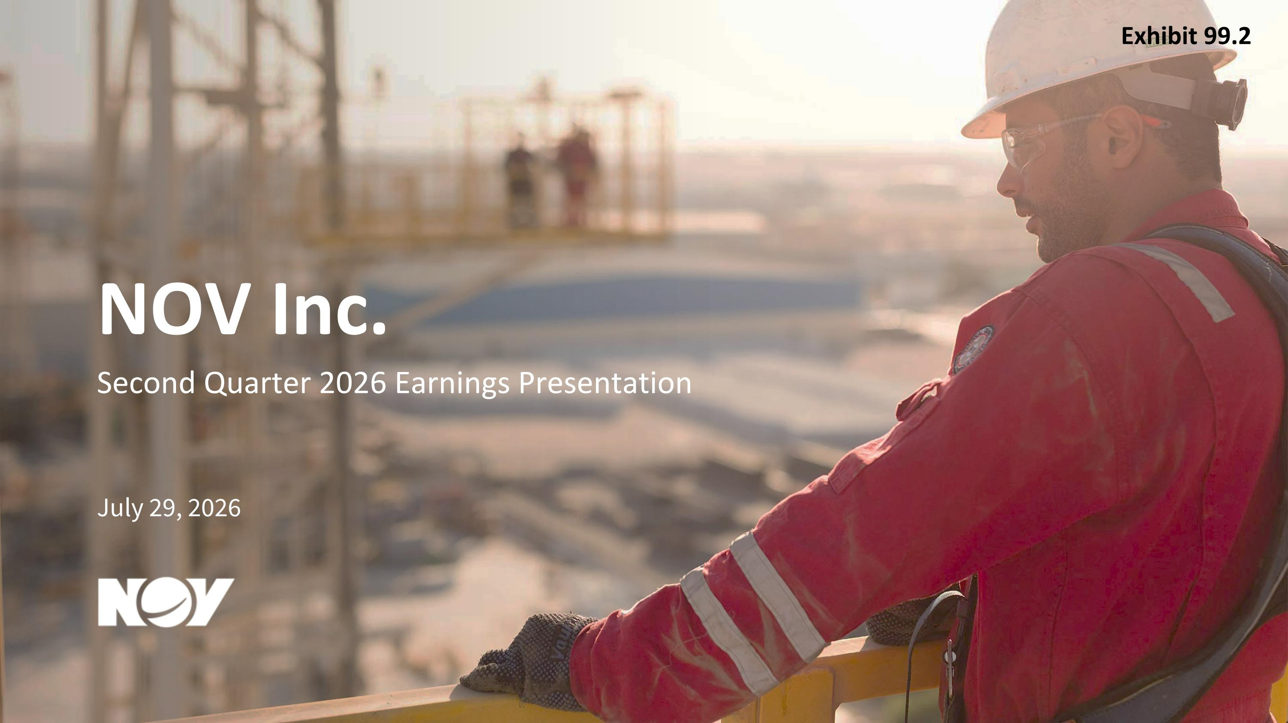
NOV Inc. Second Quarter 2026 Earnings Presentation July 29, 2026 Exhibit 99.2

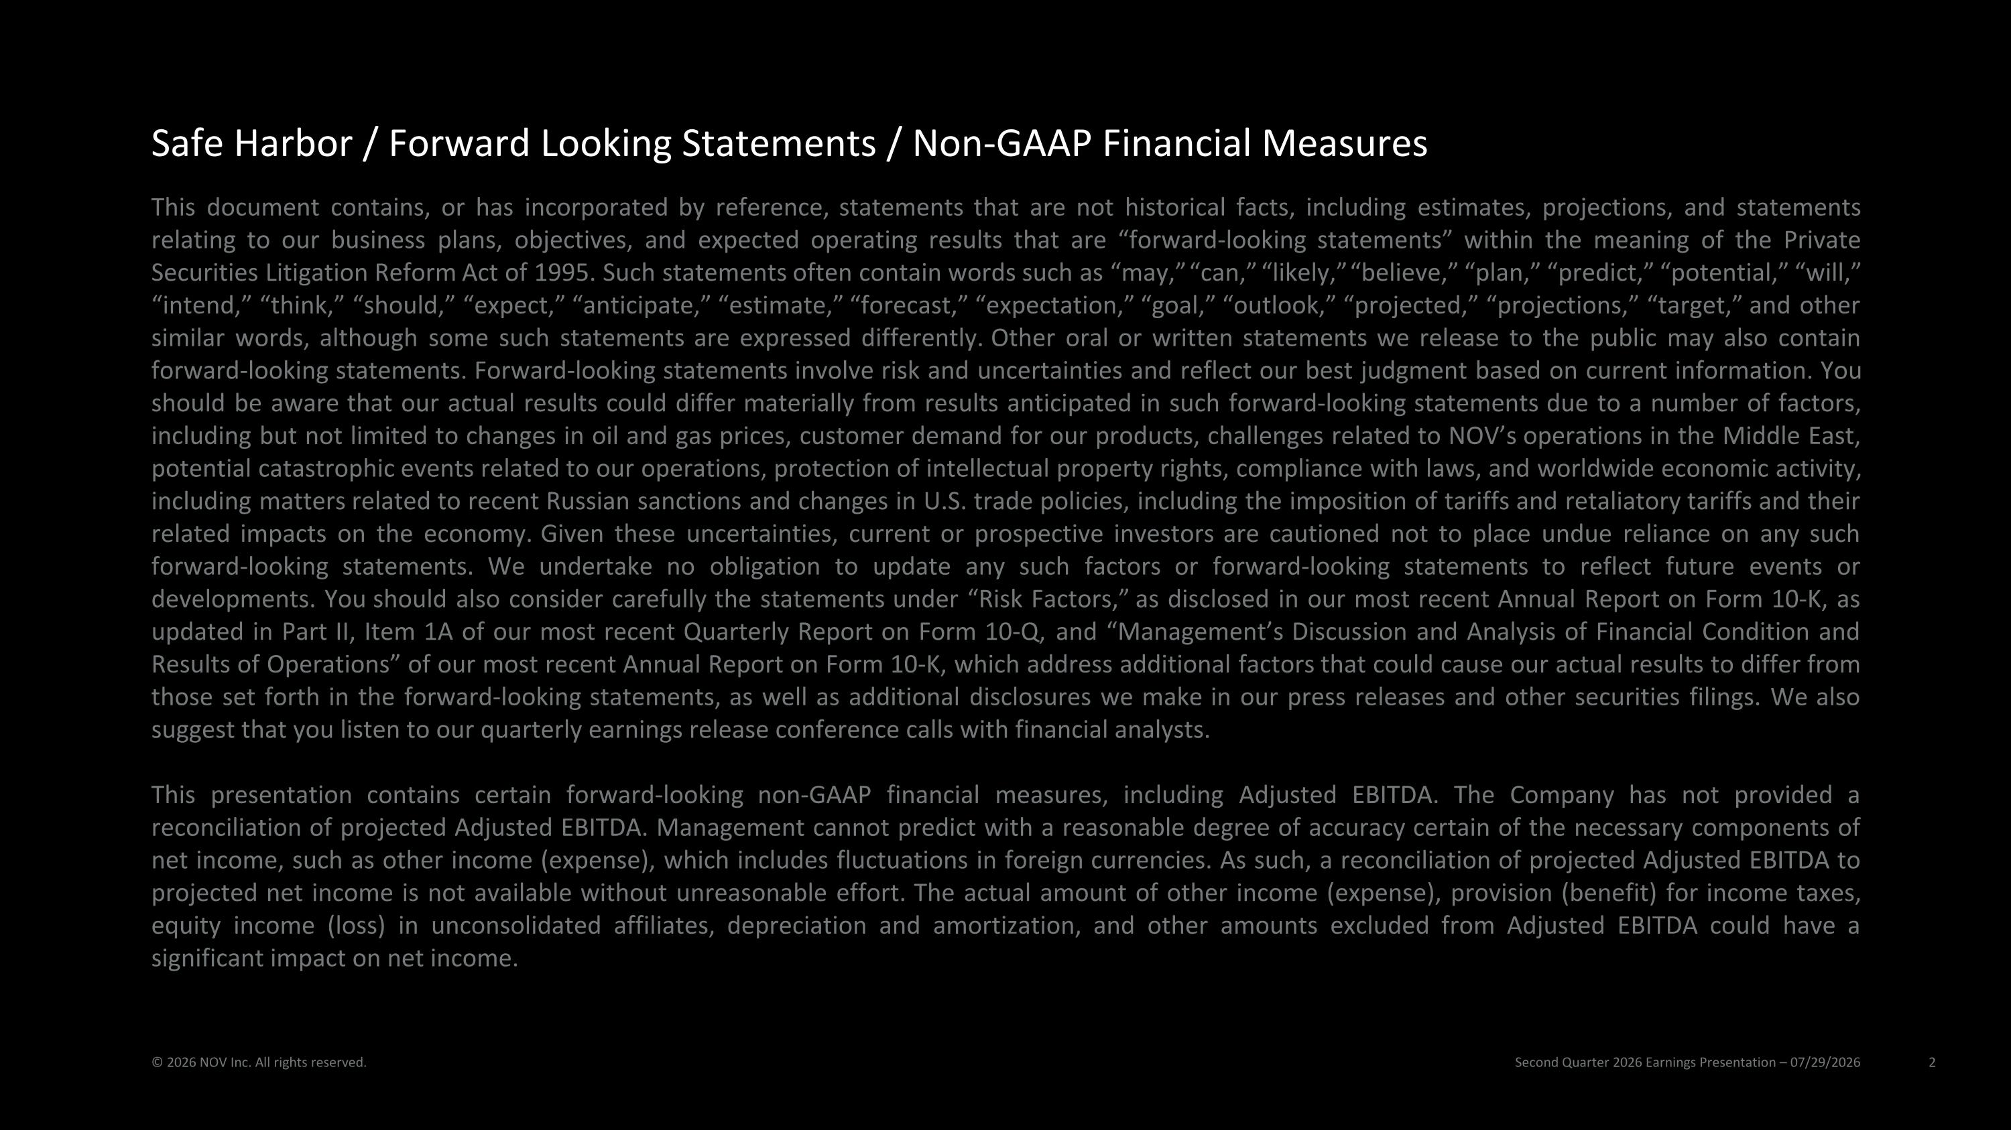
Second Quarter 2026 Earnings Presentation – 07/29/2026 © 2026 NOV Inc. All rights reserved. This document contains, or has incorporated by reference, statements that are not historical facts, including estimates, projections, and statements relating to our business plans, objectives, and expected operating results that are “forward-looking statements” within the meaning of the Private Securities Litigation Reform Act of 1995. Such statements often contain words such as “may,” “can,” “likely,” “believe,” “plan,” “predict,” “potential,” “will,” “intend,” “think,” “should,” “expect,” “anticipate,” “estimate,” “forecast,” “expectation,” “goal,” “outlook,” “projected,” “projections,” “target,” and other similar words, although some such statements are expressed differently. Other oral or written statements we release to the public may also contain forward-looking statements. Forward-looking statements involve risk and uncertainties and reflect our best judgment based on current information. You should be aware that our actual results could differ materially from results anticipated in such forward-looking statements due to a number of factors, including but not limited to changes in oil and gas prices, customer demand for our products, challenges related to NOV’s operations in the Middle East, potential catastrophic events related to our operations, protection of intellectual property rights, compliance with laws, and worldwide economic activity, including matters related to recent Russian sanctions and changes in U.S. trade policies, including the imposition of tariffs and retaliatory tariffs and their related impacts on the economy. Given these uncertainties, current or prospective investors are cautioned not to place undue reliance on any such forward-looking statements. We undertake no obligation to update any such factors or forward-looking statements to reflect future events or developments. You should also consider carefully the statements under “Risk Factors,” as disclosed in our most recent Annual Report on Form 10-K, as updated in Part II, Item 1A of our most recent Quarterly Report on Form 10-Q, and “Management’s Discussion and Analysis of Financial Condition and Results of Operations” of our most recent Annual Report on Form 10-K, which address additional factors that could cause our actual results to differ from those set forth in the forward-looking statements, as well as additional disclosures we make in our press releases and other securities filings. We also suggest that you listen to our quarterly earnings release conference calls with financial analysts. This presentation contains certain forward-looking non-GAAP financial measures, including Adjusted EBITDA. The Company has not provided a reconciliation of projected Adjusted EBITDA. Management cannot predict with a reasonable degree of accuracy certain of the necessary components of net income, such as other income (expense), which includes fluctuations in foreign currencies. As such, a reconciliation of projected Adjusted EBITDA to projected net income is not available without unreasonable effort. The actual amount of other income (expense), provision (benefit) for income taxes, equity income (loss) in unconsolidated affiliates, depreciation and amortization, and other amounts excluded from Adjusted EBITDA could have a significant impact on net income. Safe Harbor / Forward Looking Statements / Non-GAAP Financial Measures

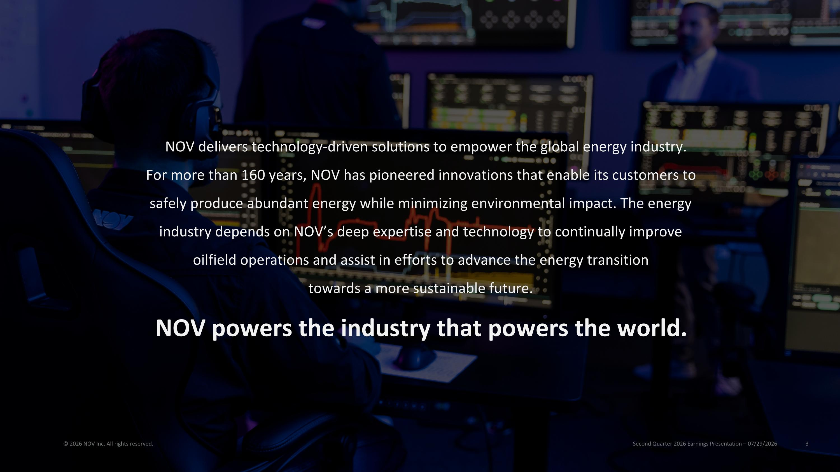
Second Quarter 2026 Earnings Presentation – 07/29/2026 © 2026 NOV Inc. All rights reserved. NOV delivers technology-driven solutions to empower the global energy industry.?For more than 160 years, NOV has pioneered innovations that enable its customers to safely produce abundant energy while minimizing environmental impact. The energy industry depends on NOV’s deep expertise and technology to continually improve oilfield operations and assist in efforts to advance the energy transition?towards a more sustainable future. NOV powers the industry that powers the world.

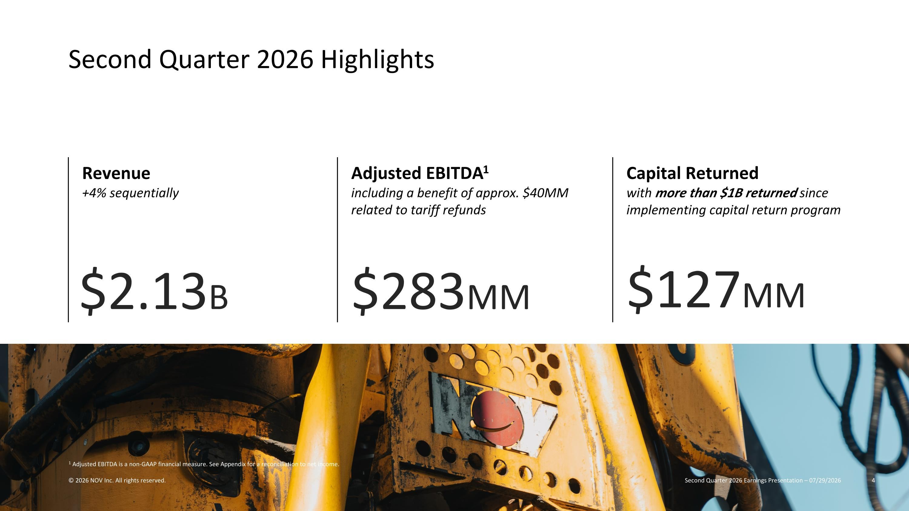
1 Adjusted EBITDA is a non-GAAP financial measure. See Appendix for a reconciliation to net income. $2.13B Revenue +4% sequentially Adjusted EBITDA1 including a benefit of approx. $40MM related to tariff refunds Capital Returned with more than $1B returned since implementing capital return program $283MM $127MM Second Quarter 2026 Highlights Second Quarter 2026 Earnings Presentation – 07/29/2026 © 2026 NOV Inc. All rights reserved.

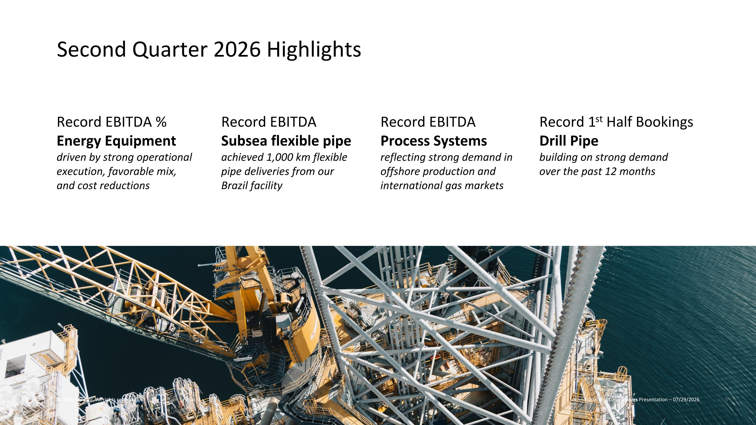
Record 1st Half Bookings?Drill Pipe?building on strong demand over the past 12 months Second Quarter 2026 Highlights Second Quarter 2026 Earnings Presentation – 07/29/2026 © 2026 NOV Inc. All rights reserved. Record EBITDA %?Energy Equipment driven by strong operational execution, favorable mix, and cost reductions Record EBITDA?Subsea flexible pipe achieved 1,000 km flexible pipe deliveries from our Brazil facility Record EBITDA Process Systems?reflecting strong demand in offshore production and international gas markets

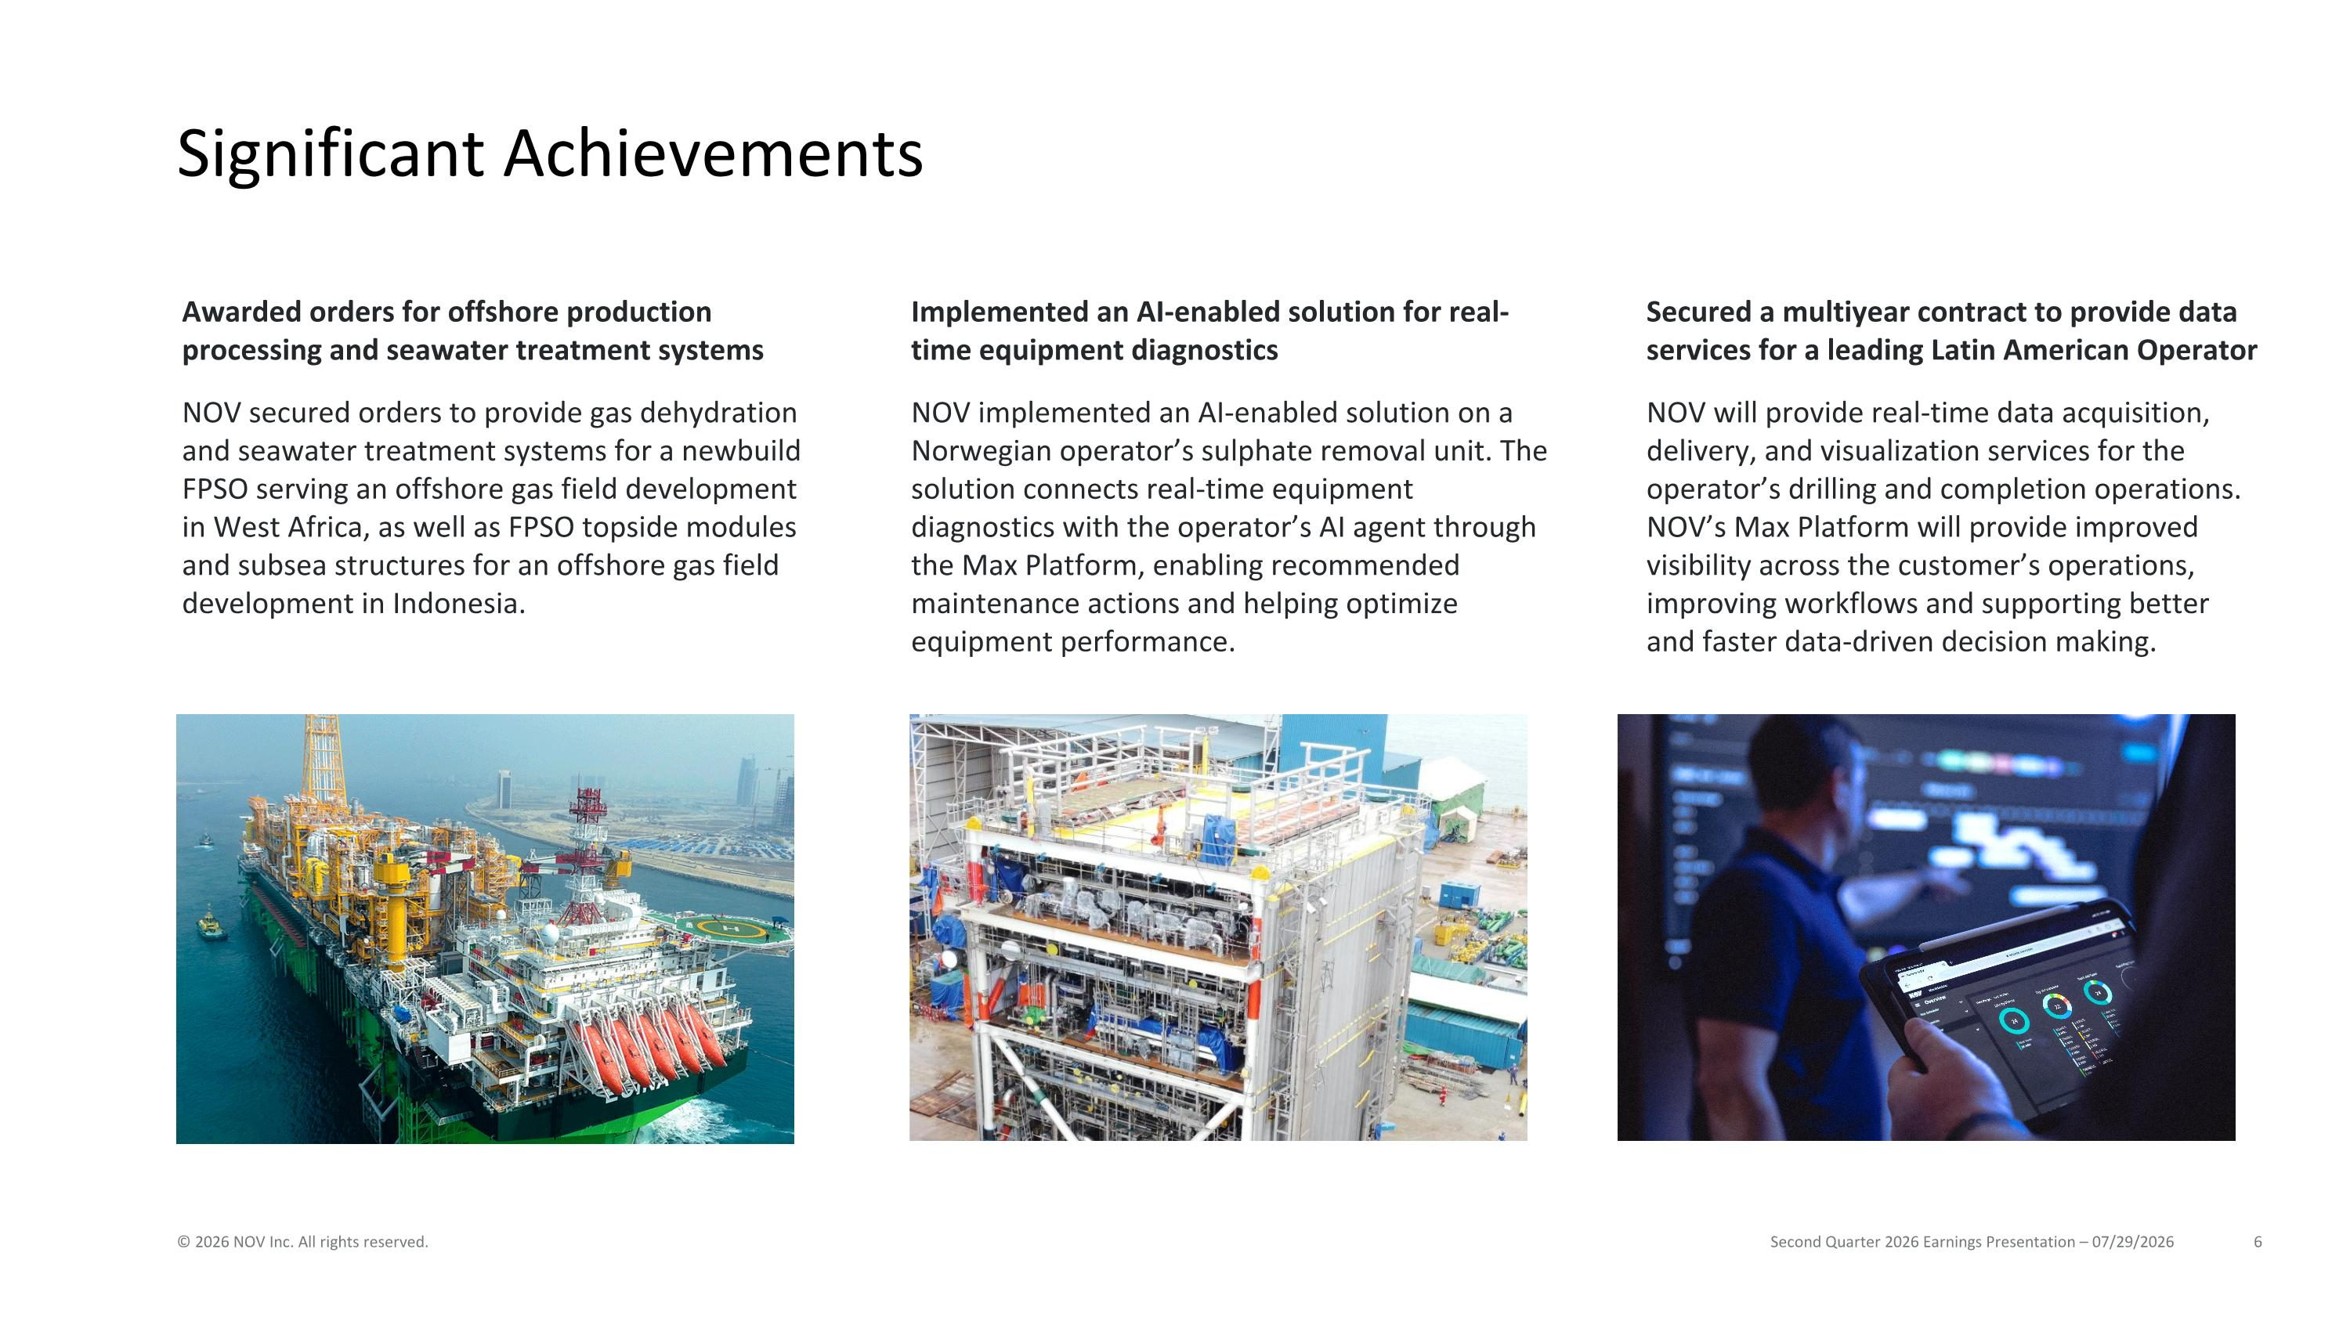
Significant Achievements Second Quarter 2026 Earnings Presentation – 07/29/2026 © 2026 NOV Inc. All rights reserved. Awarded orders for offshore production processing and seawater treatment systems NOV secured orders to provide gas dehydration and seawater treatment systems for a newbuild FPSO serving an offshore gas field development in West Africa, as well as FPSO topside modules and subsea structures for an offshore gas field development in Indonesia. Implemented an AI-enabled solution for real-time equipment diagnostics NOV implemented an AI-enabled solution on a Norwegian operator’s sulphate removal unit. The solution connects real-time equipment diagnostics with the operator’s AI agent through the Max Platform, enabling recommended maintenance actions and helping optimize equipment performance. Secured a multiyear contract to provide data services for a leading Latin American Operator NOV will provide real-time data acquisition, delivery, and visualization services for the operator’s drilling and completion operations. NOV’s Max Platform will provide improved visibility across the customer’s operations, improving workflows and supporting better and faster data-driven decision making.

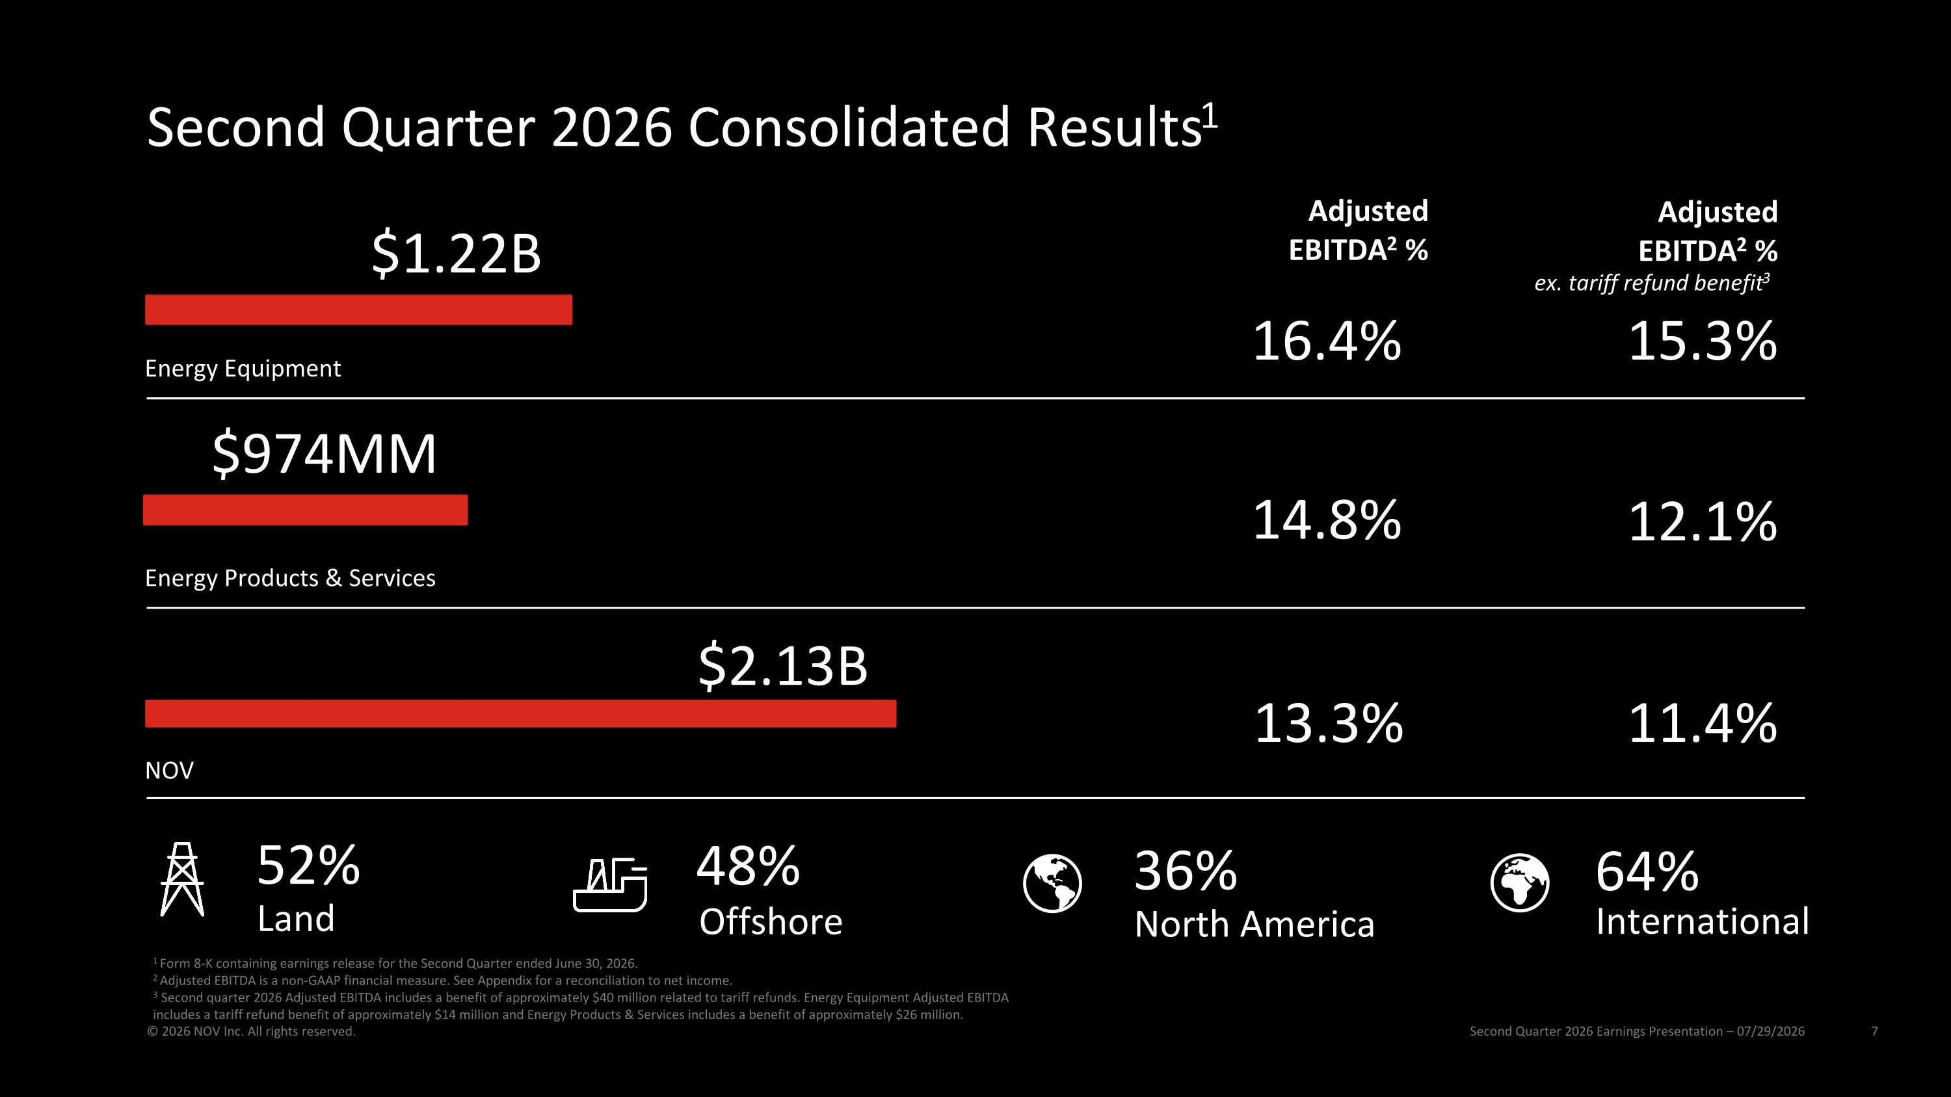
Second Quarter 2026 Consolidated Results1 Second Quarter 2026 Earnings Presentation – 07/29/2026 © 2026 NOV Inc. All rights reserved. $974MM $1.22B Energy Equipment Energy Products & Services 16.4% 15.3% 14.8% 12.1% 36% North America 64% International 52% Land 48% Offshore $2.13B NOV 11.4% 13.3% 1 Form 8-K containing earnings release for the Second Quarter ended June 30, 2026. 2 Adjusted EBITDA is a non-GAAP financial measure. See Appendix for a reconciliation to net income. 3 Second quarter 2026 Adjusted EBITDA includes a benefit of approximately $40 million related to tariff refunds. Energy Equipment Adjusted EBITDA includes a tariff refund benefit of approximately $14 million and Energy Products & Services includes a benefit of approximately $26 million. Adjusted EBITDA2 % Adjusted EBITDA2 % ex. tariff refund benefit3

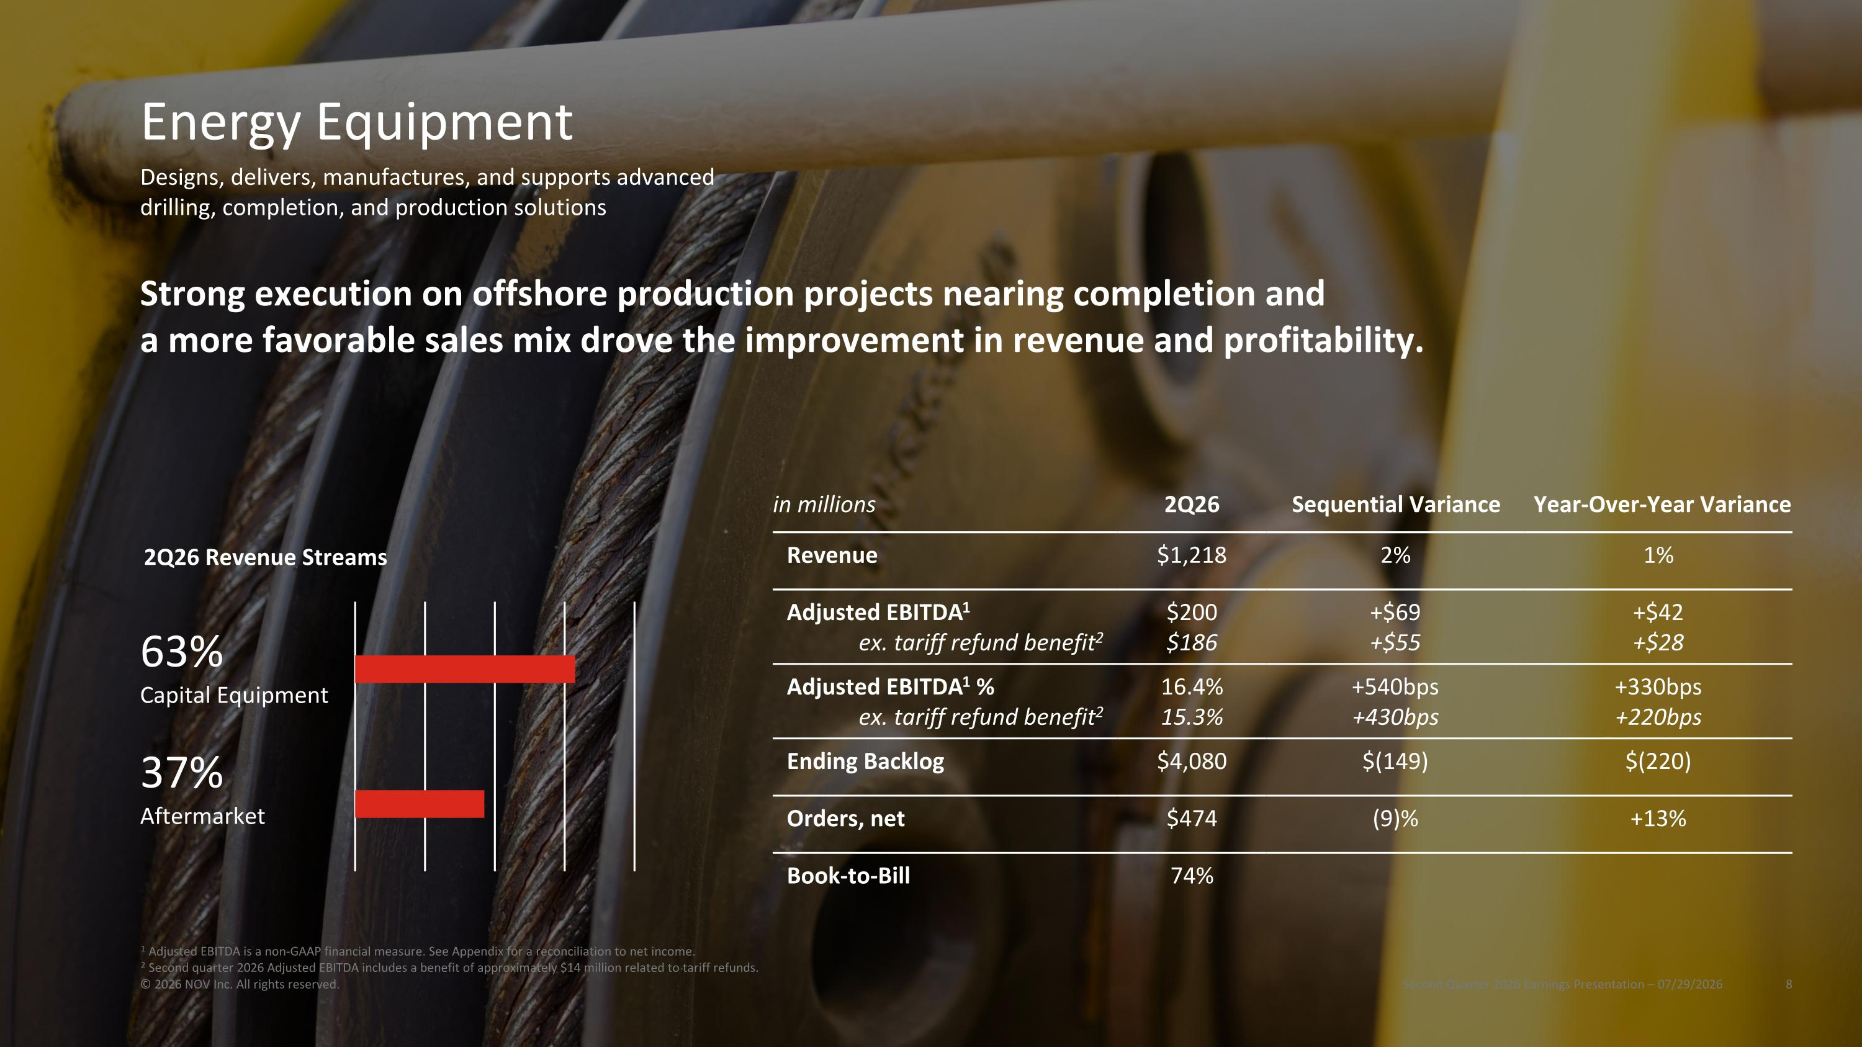
in millions 2Q26 Sequential Variance Year-Over-Year Variance Revenue $1,218 2% 1% Adjusted EBITDA1 ex. tariff refund benefit2 $200 $186 +$69 +$55 +$42 +$28 Adjusted EBITDA1 % ex. tariff refund benefit2 16.4% 15.3% +540bps +430bps +330bps +220bps Ending Backlog $4,080 $(149) $(220) Orders, net $474 (9)% +13% Book-to-Bill 74% Strong execution on offshore production projects nearing completion and a more favorable sales mix drove the improvement in revenue and profitability. 2Q26 Revenue Streams 37%?Aftermarket 63%?Capital Equipment Energy Equipment Second Quarter 2026 Earnings Presentation – 07/29/2026 © 2026 NOV Inc. All rights reserved. Designs, delivers, manufactures, and supports advanced drilling, completion, and production solutions 1 Adjusted EBITDA is a non-GAAP financial measure. See Appendix for a reconciliation to net income. 2 Second quarter 2026 Adjusted EBITDA includes a benefit of approximately $14 million related to tariff refunds.

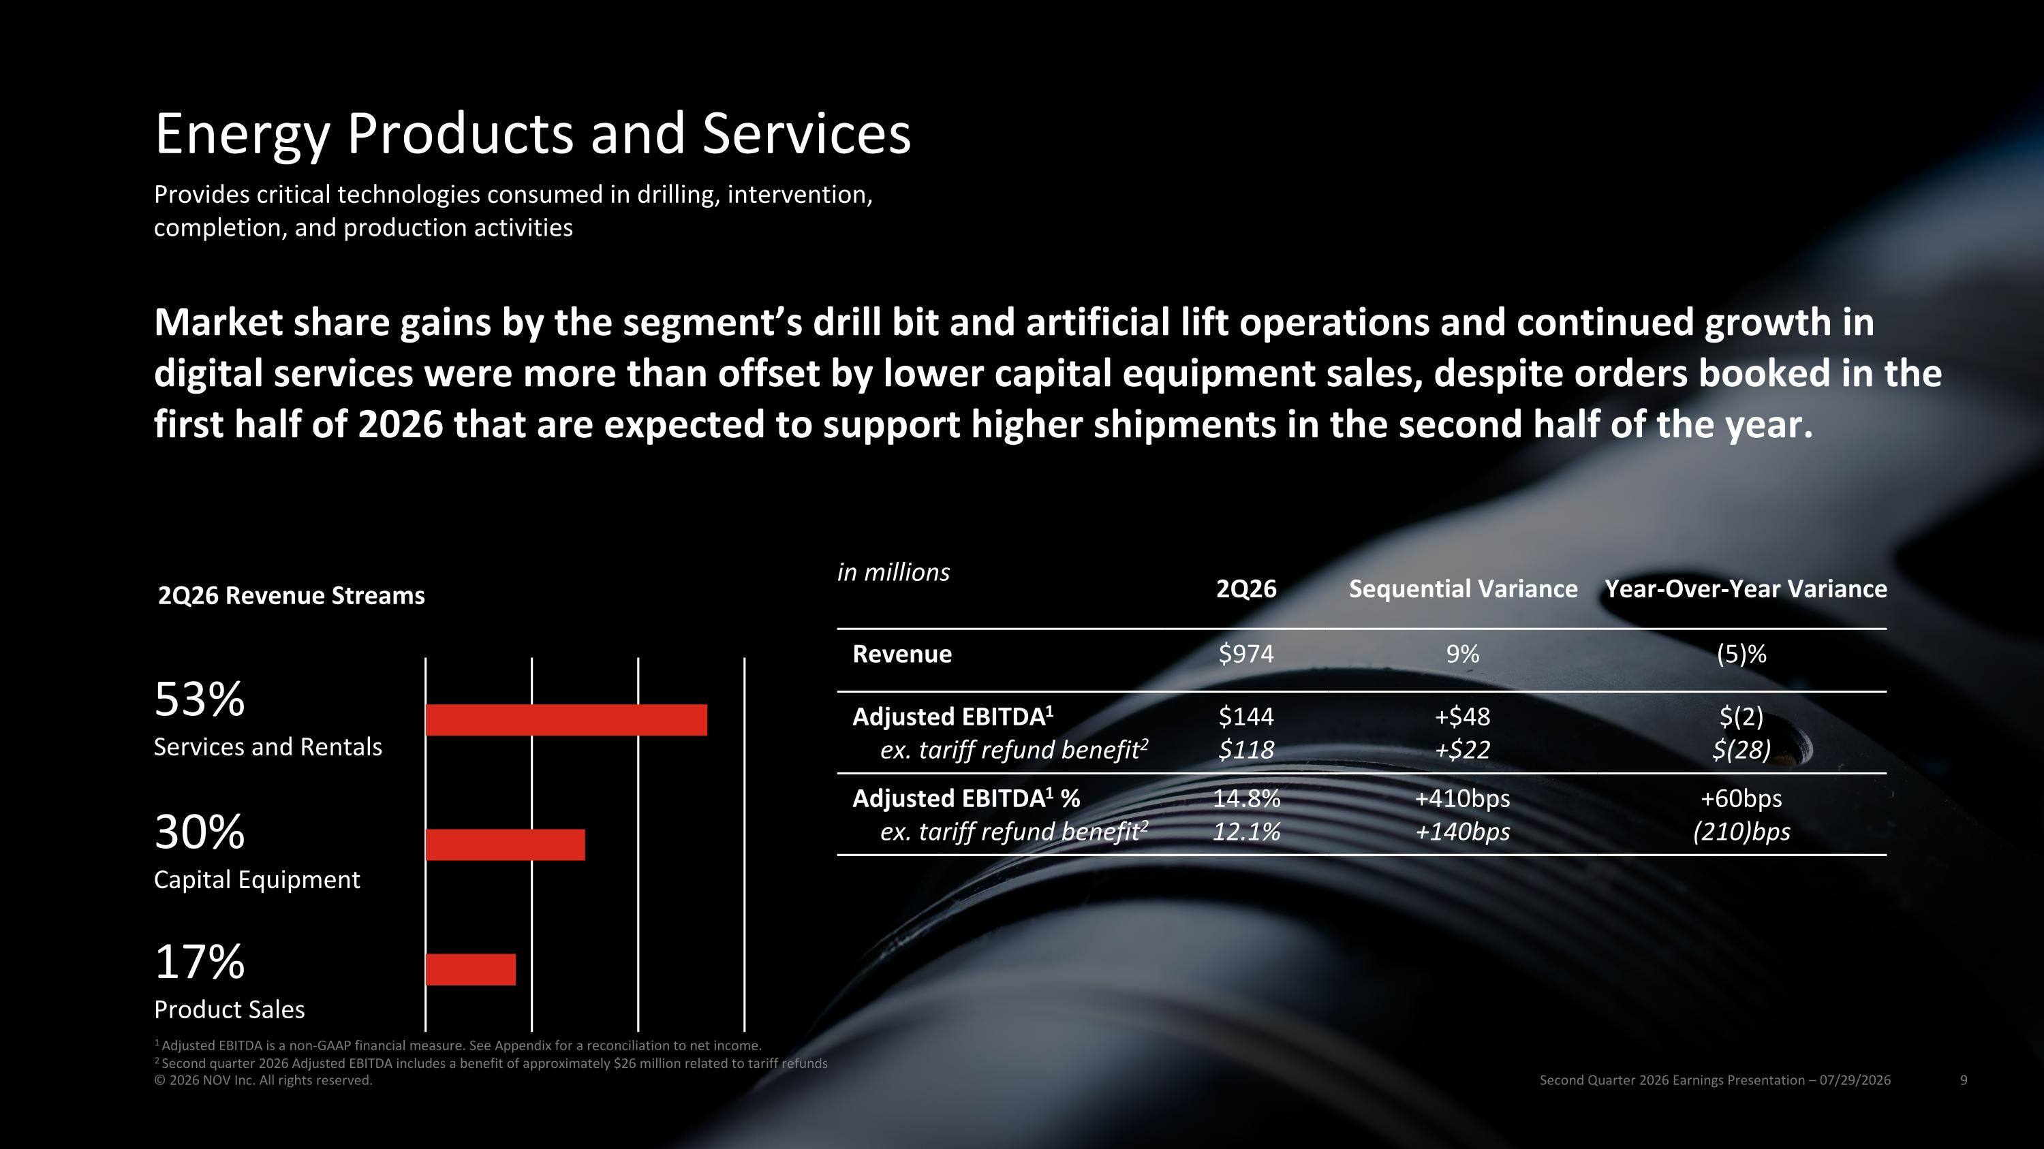
in millions 2Q26 Sequential Variance Year-Over-Year Variance Revenue $974 9% (5)% Adjusted EBITDA1 ex. tariff refund benefit2 $144 $118 +$48 +$22 $(2) $(28) Adjusted EBITDA1 % ex. tariff refund benefit2 14.8% 12.1% +410bps +140bps +60bps (210)bps Market share gains by the segment’s drill bit and artificial lift operations and continued growth in digital services were more than offset by lower capital equipment sales, despite orders booked in the first half of 2026 that are expected to support higher shipments in the second half of the year. 2Q26 Revenue Streams 30%?Capital Equipment 53%?Services and Rentals 17%?Product Sales Energy Products and Services Second Quarter 2026 Earnings Presentation – 07/29/2026 © 2026 NOV Inc. All rights reserved. Provides critical technologies consumed in drilling, intervention, completion, and production activities 1 Adjusted EBITDA is a non-GAAP financial measure. See Appendix for a reconciliation to net income. 2 Second quarter 2026 Adjusted EBITDA includes a benefit of approximately $26 million related to tariff refunds

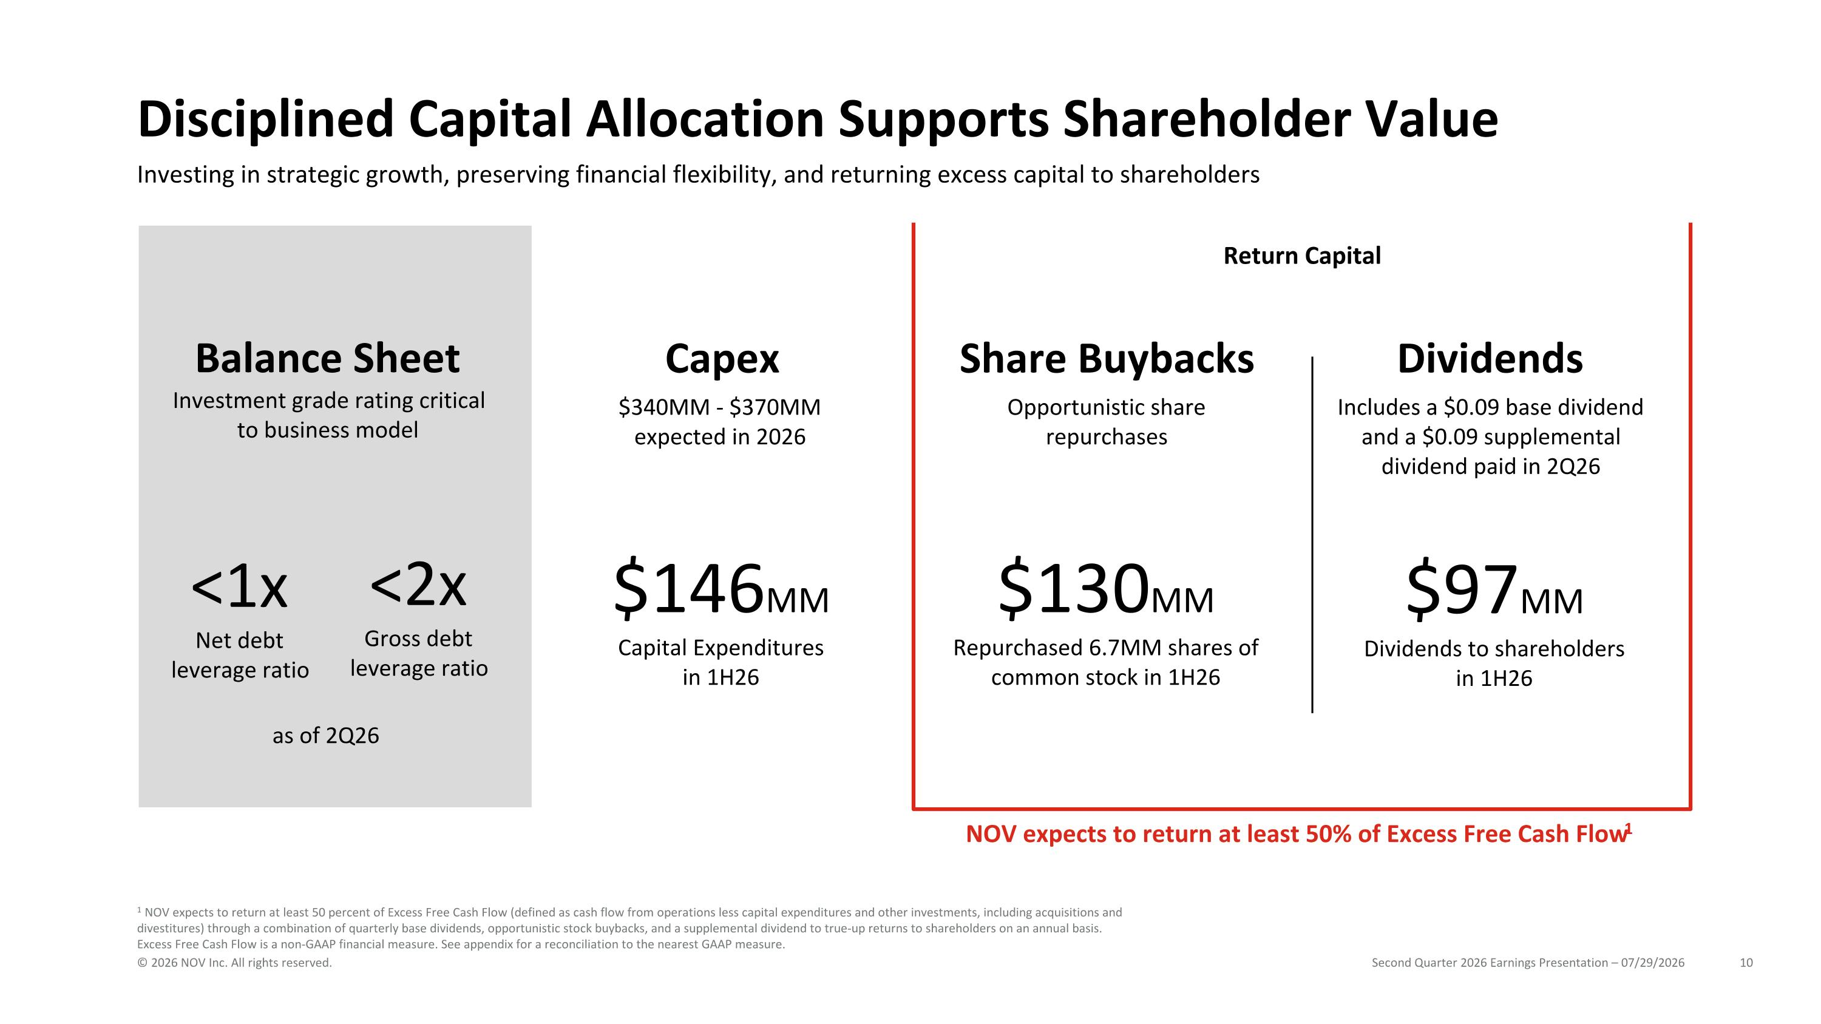
Disciplined Capital Allocation Supports Shareholder Value Investing in strategic growth, preserving financial flexibility, and returning excess capital to shareholders NOV expects to return at least 50% of Excess Free Cash Flow1 1 NOV expects to return at least 50 percent of Excess Free Cash Flow (defined as cash flow from operations less capital expenditures and other investments, including acquisitions and divestitures) through a combination of quarterly base dividends, opportunistic stock buybacks, and a supplemental dividend to true-up returns to shareholders on an annual basis. Excess Free Cash Flow is a non-GAAP financial measure. See appendix for a reconciliation to the nearest GAAP measure. $340MM - $370MM expected in 2026 Opportunistic share repurchases Includes a $0.09 base dividend and a $0.09 supplemental dividend paid in 2Q26 Balance Sheet Capex Share Buybacks Dividends Investment grade rating critical to business model $146MM Capital Expenditures in 1H26 $130MM Repurchased 6.7MM shares of common stock in 1H26 <1x Net debt?leverage ratio <2x Gross debt leverage ratio as of 2Q26 $97MM Dividends to shareholders in 1H26 Return Capital Second Quarter 2026 Earnings Presentation – 07/29/2026 © 2026 NOV Inc. All rights reserved.

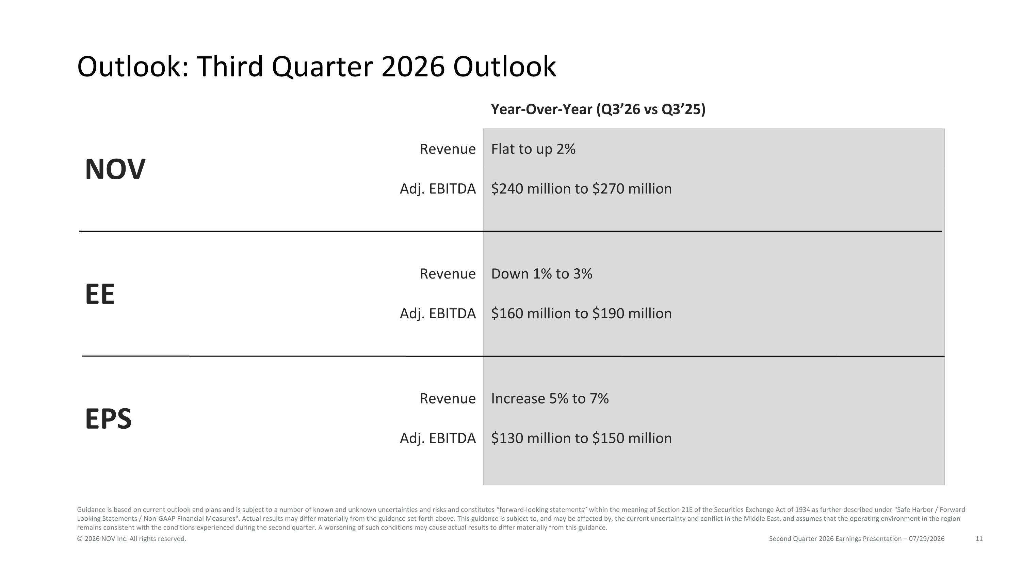
Outlook: Third Quarter 2026 Outlook Second Quarter 2026 Earnings Presentation – 07/29/2026 © 2026 NOV Inc. All rights reserved. Year-Over-Year (Q3’26 vs Q3’25) NOV Revenue Flat to up 2% Adj. EBITDA $240 million to $270 million EE Revenue Down 1% to 3% Adj. EBITDA $160 million to $190 million EPS Revenue Increase 5% to 7% Adj. EBITDA $130 million to $150 million Guidance is based on current outlook and plans and is subject to a number of known and unknown uncertainties and risks and constitutes “forward-looking statements” within the meaning of Section 21E of the Securities Exchange Act of 1934 as further described under "Safe Harbor / Forward Looking Statements / Non-GAAP Financial Measures". Actual results may differ materially from the guidance set forth above. This guidance is subject to, and may be affected by, the current uncertainty and conflict in the Middle East, and assumes that the operating environment in the region remains consistent with the conditions experienced during the second quarter. A worsening of such conditions may cause actual results to differ materially from this guidance.

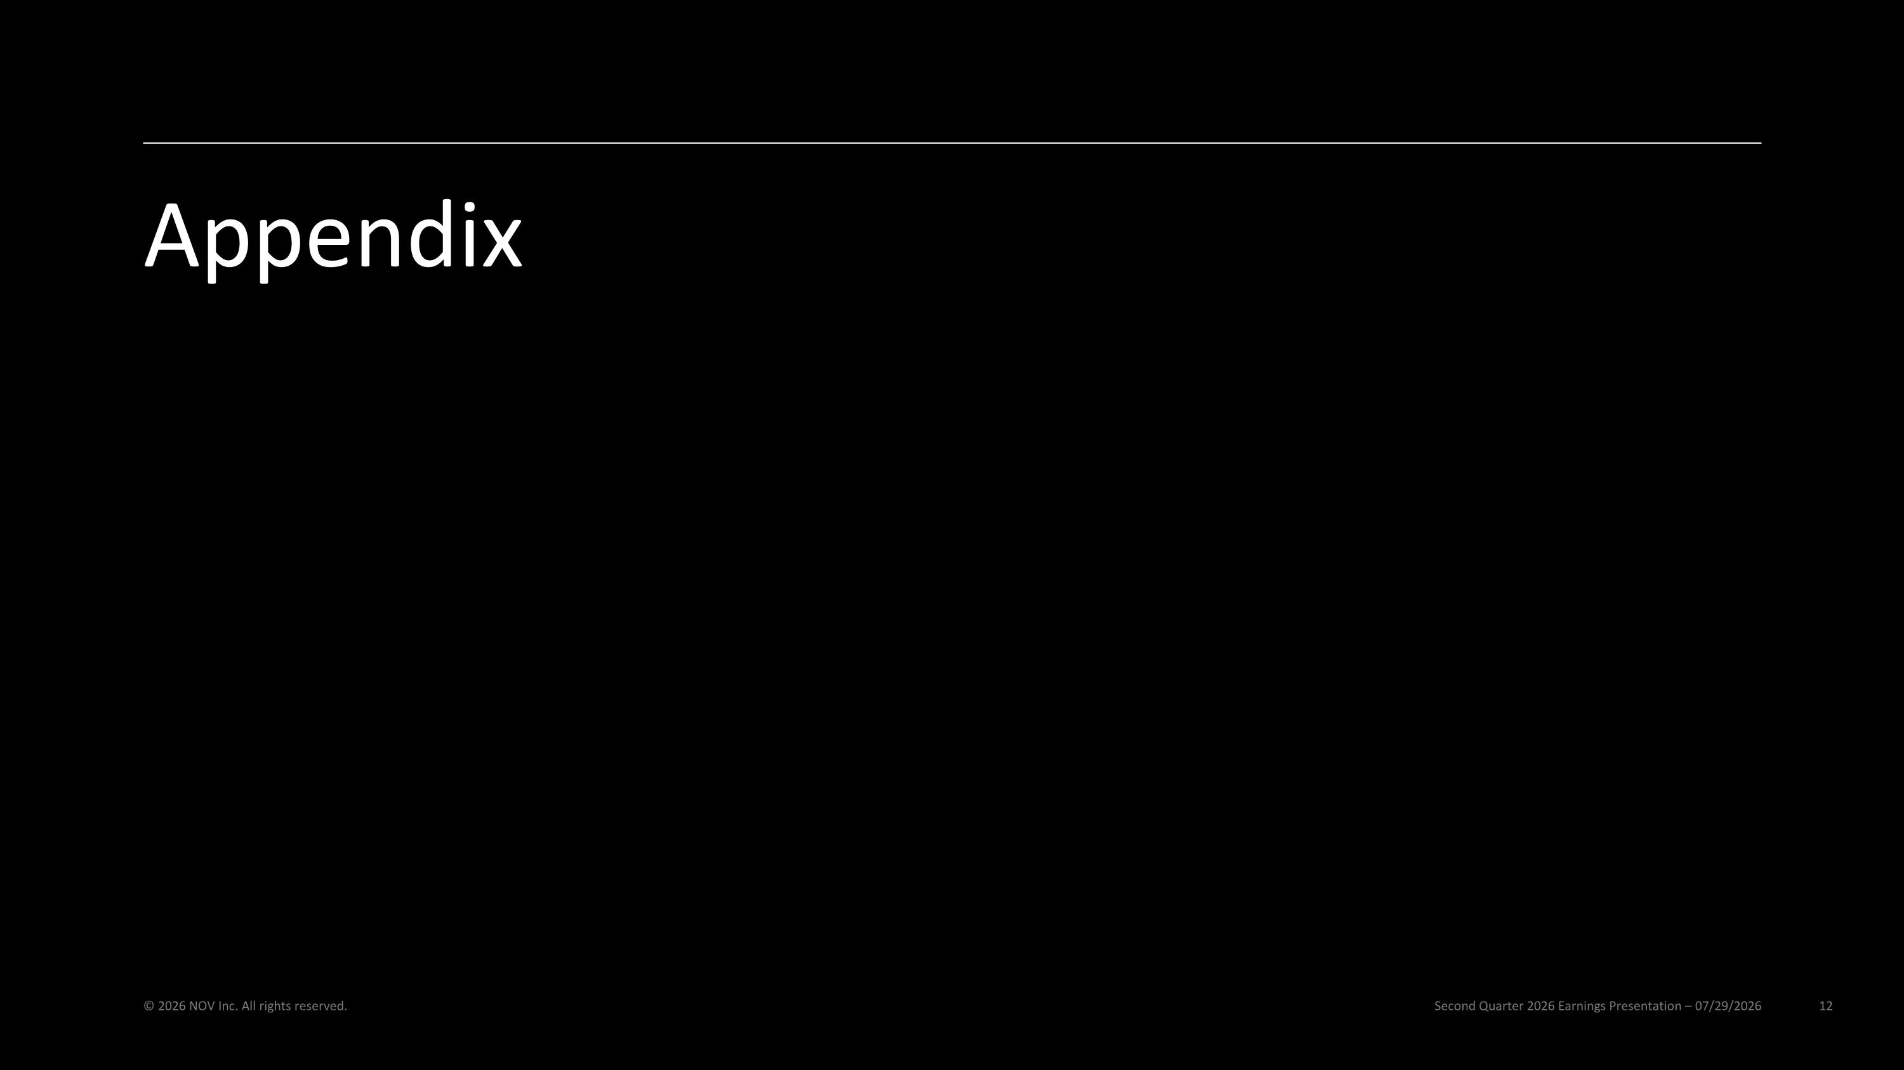
Appendix Second Quarter 2026 Earnings Presentation – 07/29/2026 © 2026 NOV Inc. All rights reserved.

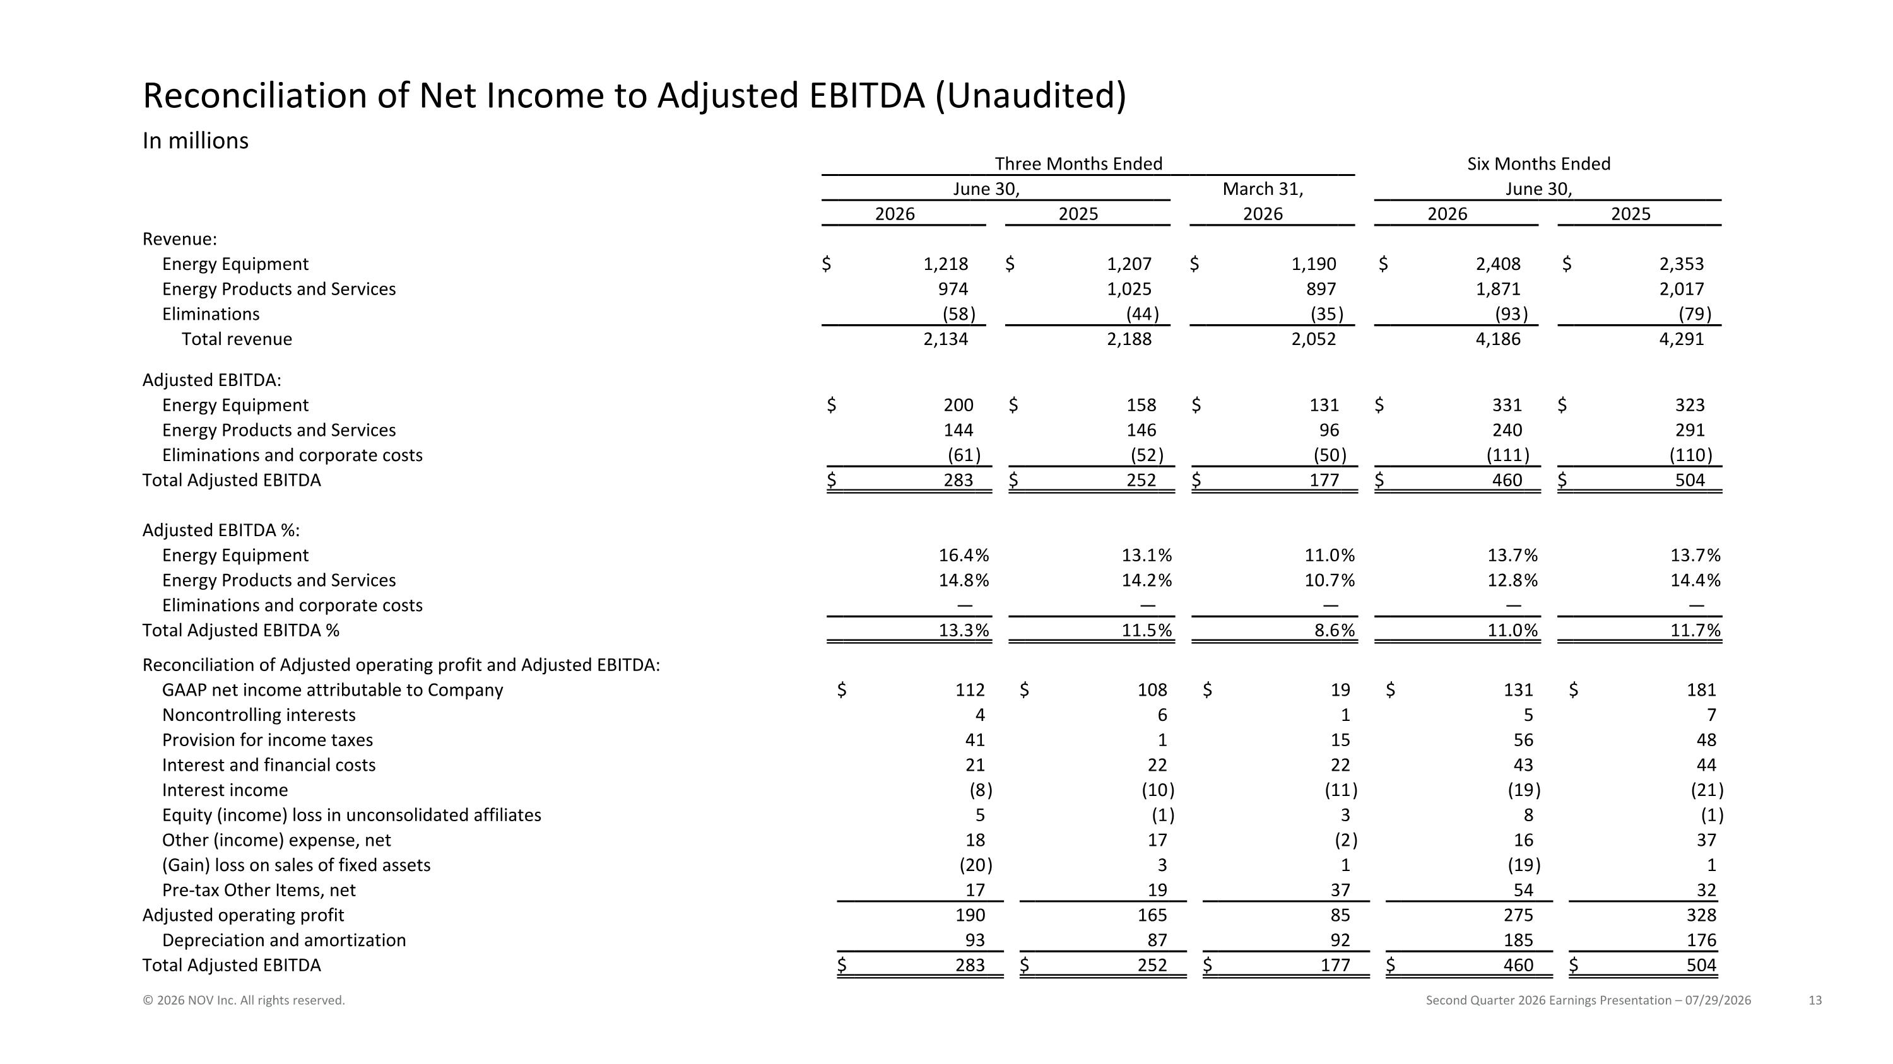
Reconciliation of Net Income to Adjusted EBITDA (Unaudited) Second Quarter 2026 Earnings Presentation – 07/29/2026 © 2026 NOV Inc. All rights reserved. In millions Three Months Ended Six Months Ended June 30, March 31, June 30, 2026 2025 2026 2026 2025 Revenue: Energy Equipment $ 1,218 $ 1,207 $ 1,190 $ 2,408 $ 2,353 Energy Products and Services 974 1,025 897 1,871 2,017 Eliminations (58 ) (44 ) (35 ) (93 ) (79 ) Total revenue 2,134 2,188 2,052 4,186 4,291 Adjusted EBITDA: Energy Equipment $ 200 $ 158 $ 131 $ 331 $ 323 Energy Products and Services 144 146 96 240 291 Eliminations and corporate costs (61 ) (52 ) (50 ) (111 ) (110 ) Total Adjusted EBITDA $ 283 $ 252 $ 177 $ 460 $ 504 Adjusted EBITDA %: Energy Equipment 16.4 % 13.1 % 11.0 % 13.7 % 13.7 % Energy Products and Services 14.8 % 14.2 % 10.7 % 12.8 % 14.4 % Eliminations and corporate costs — — — — — Total Adjusted EBITDA % 13.3 % 11.5 % 8.6 % 11.0 % 11.7 % Reconciliation of Adjusted operating profit and Adjusted EBITDA: GAAP net income attributable to Company $ 112 $ 108 $ 19 $ 131 $ 181 Noncontrolling interests 4 6 1 5 7 Provision for income taxes 41 1 15 56 48 Interest and financial costs 21 22 22 43 44 Interest income (8 ) (10 ) (11 ) (19 ) (21 ) Equity (income) loss in unconsolidated affiliates 5 (1 ) 3 8 (1 ) Other (income) expense, net 18 17 (2 ) 16 37 (Gain) loss on sales of fixed assets (20 ) 3 1 (19 ) 1 Pre-tax Other Items, net 17 19 37 54 32 Adjusted operating profit 190 165 85 275 328 Depreciation and amortization 93 87 92 185 176 Total Adjusted EBITDA $ 283 $ 252 $ 177 $ 460 $ 504

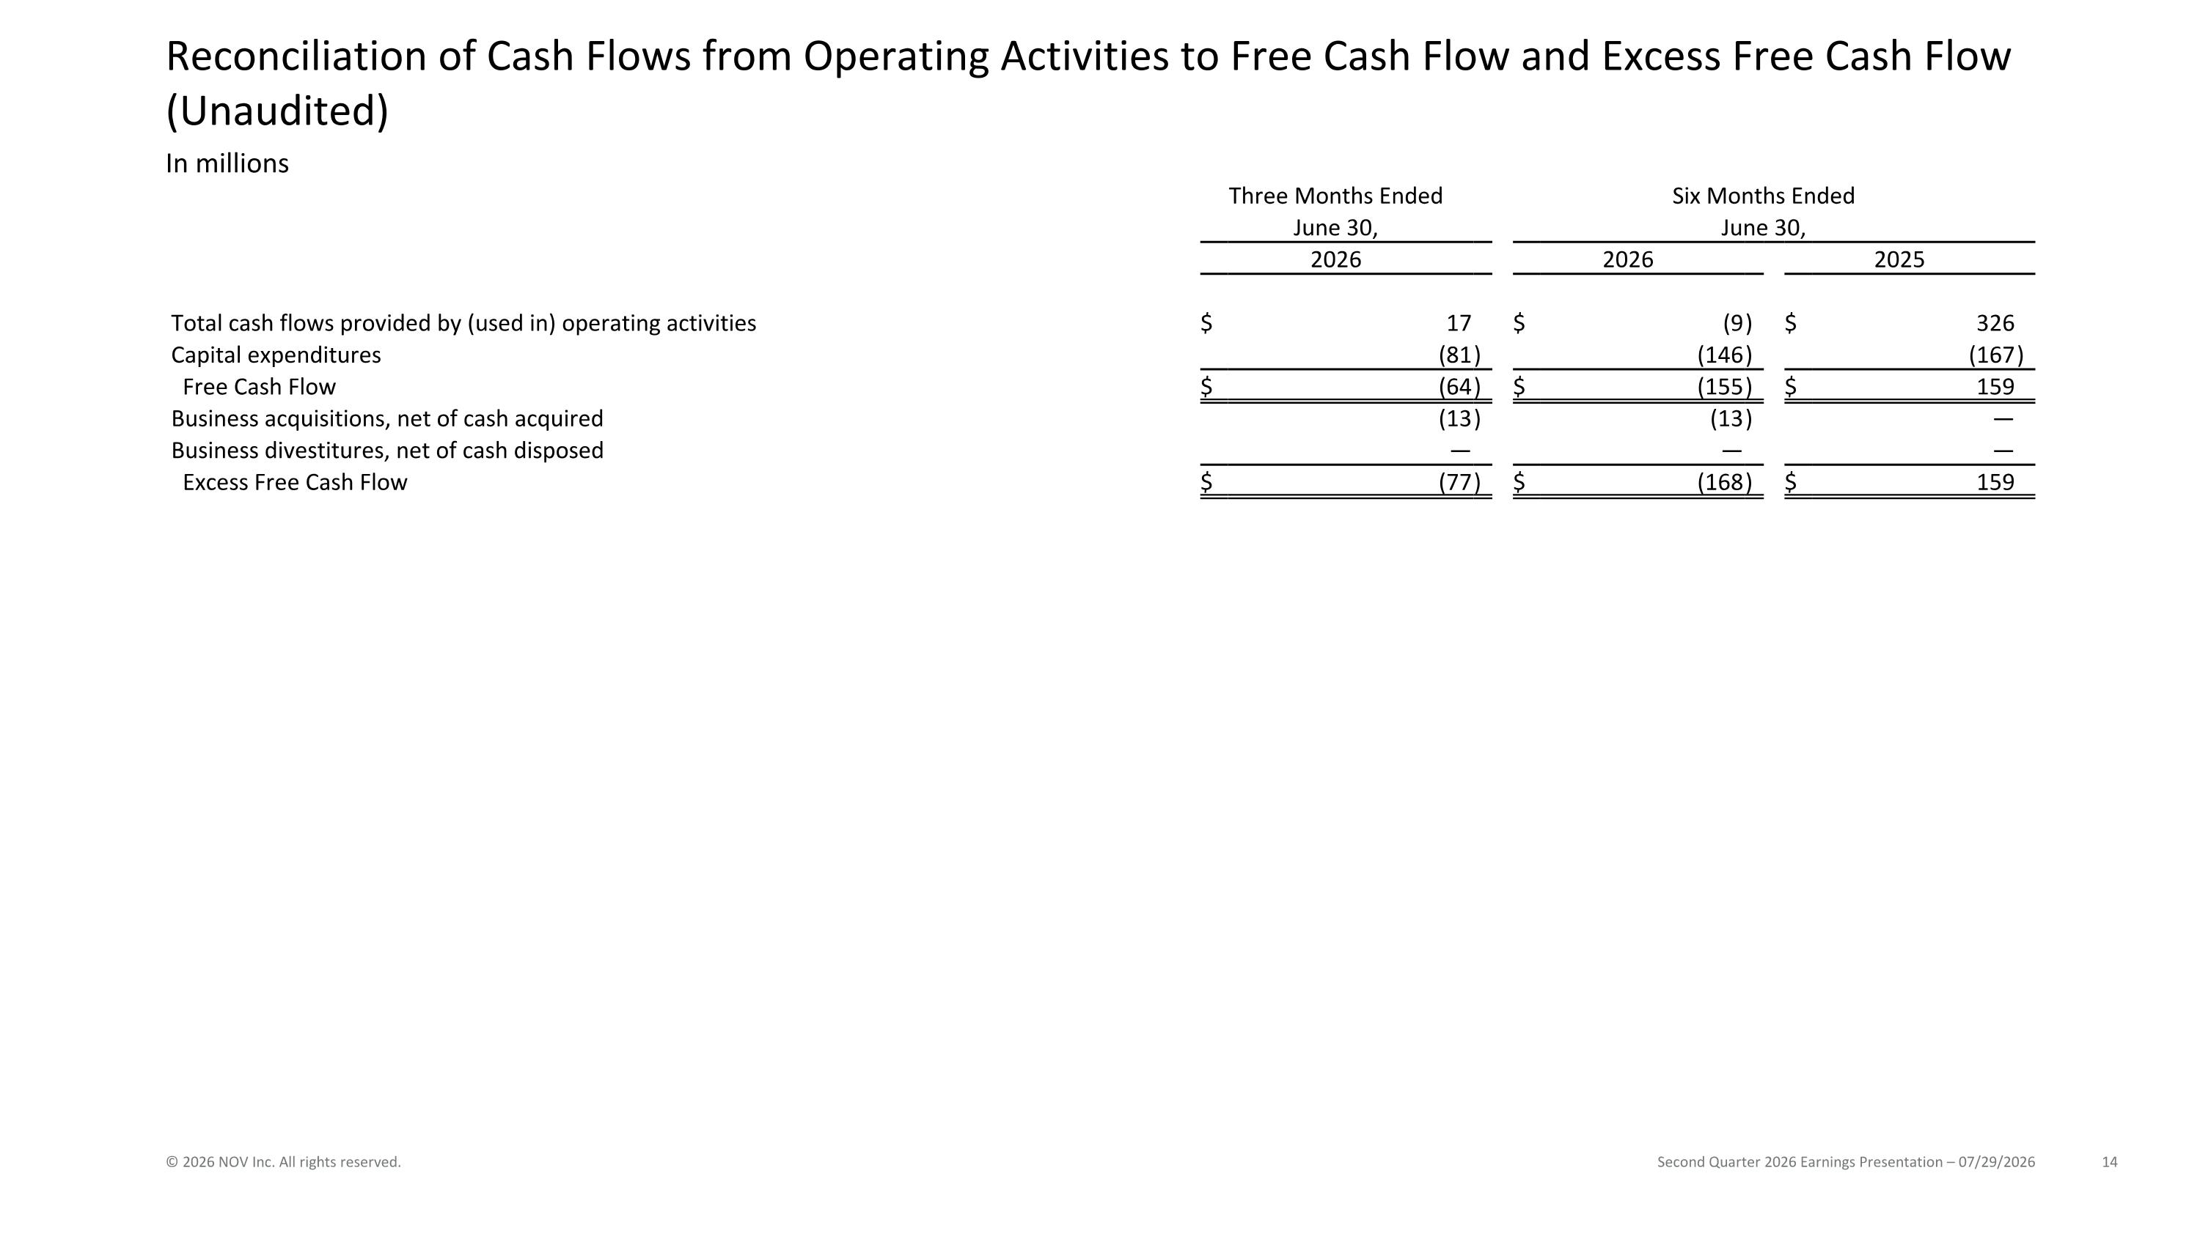
Reconciliation of Cash Flows from Operating Activities to Free Cash Flow and Excess Free Cash Flow (Unaudited) Second Quarter 2026 Earnings Presentation – 07/29/2026 © 2026 NOV Inc. All rights reserved. In millions Three Months Ended Six Months Ended June 30, June 30, 2026 2026 2025 Total cash flows provided by (used in) operating activities $ 17 $ (9 ) $ 326 Capital expenditures (81 ) (146 ) (167 ) Free Cash Flow $ (64 ) $ (155 ) $ 159 Business acquisitions, net of cash acquired (13 ) (13 ) — Business divestitures, net of cash disposed — — — Excess Free Cash Flow $ (77 ) $ (168 ) $ 159


Second Quarter 2026 Earnings Presentation – 07/29/2026 © 2026 NOV Inc. All rights reserved.

